THE UNIVERSITY OF BAMENDA



COLLEGE OF TECHNOLOGY

(COLTECH)

DEPARTME
NT OF
COMPUTER ENGINEERING

CyberForge: A Real-Time Agentic AI System for Web Threat Detection and User Protection

A Dissertation submitted to the Department of Computer Engineering of the
College of Technology in partial Fulfillment of the requirements for the award of a Master’s Degree in Computer Engineering – Information Technology and Cyber Security

BY:
CHE HAGGAI NGHA KANG
REGISTRATION NUMBER: UBA24PP134
(B.Tech in Computer Engineering)

SUPERVISED BY:
Prof. ONABID MATHIAS AKONG
ASSOCIATE PROFESSOR

JUNE, 2026

DECLARATION
I, CHE HAGGAI NGHA KANG (Registration Number: UBA24PP134), hereby declare that this dissertation entitled “CyberForge: A Real-Time Agentic AI System for Web Threat Detection and User Protection” is my own original work. It has been written by me and has not been submitted, in part or in whole, for the award of any other degree or qualification at this university or any other institution. All sources of information used in this work have been duly acknowledged through references.

Signature: …………………………………. Date: ………………………………….
CHE HAGGAI NGHA KANG
(Candidate)

CERTIFICATION
This is to certify that this dissertation entitled “CyberForge: A Real-Time Agentic AI System for Web Threat Detection and User Protection” was carried out by CHE HAGGAI NGHA KANG (Registration Number: UBA24PP134) in the Department of Computer Engineering, College of Technology, The University of Bamenda, under our supervision.

Signature: …………………………………. Date: ………………………………….
Prof ONABID MATHIAS AKONG
(Supervisor)

Signature: …………………………………. Date: ………………………………….
[Dr SUH CHARLSE FORBACHA]
(Head of Department)

ABSTRACT
CyberForge is a web-threat analysis and user-protection research system that combines specialised analysers, contextual evidence and human-readable explanations. The original prototype coordinated eight specialist agents through a three-stage directed acyclic graph, followed by a Reporter. Its reported evaluation on 300 URLs (150 benign and 150 harmful) yielded 94.7% accuracy, 97.9% precision, 91.3% recall and a 2.0% false-positive rate, with mean end-to-end latency of 4.05 seconds. These are retained as historical prototype results, not measurements of the revised implementation. A source review dated 18 October 2026 identifies the current implementation as a Tauri 2/Rust desktop, a Node.js 24/Express backend, a FastAPI Hugging Face service, a shared Rust core, a scoped CLI and a grant-controlled stdio MCP adapter. The ML service combines supervised gradient-boosted URL classifiers, unsupervised IsolationForest scoring, externally pretrained BERT and Qwen inference, and explicit heuristic fallbacks. Current controls include consent-based collection, authenticated workspace access, device enrollment and signed commands, evidence records, and capability-aware status reporting. Memory supplies retrieval context; it does not update model weights. The current implementation requires fresh held-out evaluation and packaged/live-service acceptance before historical performance can be attributed to it.
Keywords: agentic AI; phishing detection; multi-agent systems; threat intelligence; real-time protection; explainable security

RESUME
CyberForge : un système d’IA agentique en temps réel pour la détection des menaces web et la protection des utilisateurs
CyberForge est un système de recherche consacré à l’analyse des menaces web et à la protection des utilisateurs. Le prototype initial coordonnait huit agents spécialisés dans un graphe orienté acyclique en trois étapes, suivi d’un agent rapporteur. L’évaluation historique de 300 URL (150 légitimes et 150 malveillantes) rapporte une exactitude de 94,7 %, une précision de 97,9 %, un rappel de 91,3 %, un taux de faux positifs de 2,0 % et une latence moyenne de 4,05 secondes. Ces résultats ne constituent pas une nouvelle évaluation du système révisé. La revue du code du 18 octobre 2026 identifie un client Tauri 2/Rust, un backend Node.js 24/Express, un service FastAPI sur Hugging Face, un noyau Rust partagé, une interface en ligne de commande et un adaptateur MCP stdio soumis à autorisation. Le service ML associe classification supervisée, détection non supervisée d’anomalies, inférence avec BERT et Qwen préentraînés et heuristiques explicitement identifiées. La collecte dépend du consentement; les actions et les données sont soumises à des contrôles d’accès. La mémoire conserve du contexte sans réentraîner les modèles. Une nouvelle évaluation indépendante et des essais de la version installée restent nécessaires avant de généraliser les résultats historiques à cette version.
Mots-clés : IA agentique ; détection du phishing ; systèmes multi-agents ; renseignement sur les menaces ; protection en temps réel ; sécurité explicable

DEDICATION
This work is dedicated to my mother, NGAH EVELYN NJUA, whose love, sacrifice, and unshakable faith in me have carried me through every stage of my education. You gave up so much so that I could sit in a classroom, and every page of this dissertation is a fruit of your prayers and your patience.

To my elder brothers, KUM MEH FRANCIS and CHE FLORIMUND KUM-KAH, who stood in for me in countless ways, encouraged me when the road was hard, and reminded me that giving up was never an option.

And to my elder sister, CHE EGLAH MBONG, for her constant care, quiet strength, and the example she set for me long before I understood what perseverance meant.

This achievement is not mine alone it belongs to all of you.

ACKNOWLEDGEMENTS
I sincerely thank my supervisor, Prof ONABID MATHIAS AKONG, for the patient guidance, careful corrections, and steady encouragement that shaped this work from its first idea to its final form.
I am grateful to the Head of Department and to all the lecturers of the Department of Computer Engineering, College of Technology, The University of Bamenda, for the knowledge and training they gave me throughout my studies.
I thank my family for their unending support, prayers, and sacrifices, and my friends and classmates for their helpful discussions, testing assistance, and encouragement during the long hours of development and writing.
Finally, I acknowledge the open-source community whose freely available tools, models, and data sets including Hugging Face, MITRE ATT&CK, and AlienVault OTX made it possible to build and evaluate this system.

TABLE OF CONTENTS
DECLARATION iv
CERTIFICATION v
ABSTRACT vi
RESUME vii
DEDICATION viii
ACKNOWLEDGEMENTS ix
TABLE OF CONTENTS x
LIST OF TABLES xiv
LIST OF FIGURES xv
LIST OF ABBREVIATIONS xvi
Chapter One INTRODUCTION 1
1.1 Background of the Study 1
1.2 Problem Statement 2
1.3 Research Questions 3
1.3.1 General Research Question 3
1.3.2 Specific Research Questions 3
1.4 Objectives of the Study 4
1.4.1 General Objective 4
1.4.2 Specific Objectives 4
1.5 Significance of the Study 4
1.6 Scope and Limitations of the Study 5
1.7 Definition of Key Terms 6
1.8 Arrangement of the Dissertation 9
Chapter Two LITERATURE REVIEW 11
2.1 Introduction 11
2.2 Evolution of Web Threats 12
2.3 Machine Learning in Cybersecurity 13
2.3.1 Foundational scepticism 13
2.3.2 Surveys of applied machine learning 14
2.3.3 Deep learning and Transformers 14
2.4 Related Works: Phishing Detection Approaches 15
2.5 Domain Generation Algorithms (DGA) 16
2.6 Indicator Extraction and Cyber Threat Evidence Representation 18
2.7 Structured Adversary Behaviour Mapping Using MITRE ATT&CK 19
2.8 Multi-Agent Systems and Agent-Based AI in Cybersecurity 20
2.8.1 Classical idea of multi-agent systems 20
2.8.2 Agentic AI and modern systems 20
2.8.3 How agents are coordinated 21
2.9 Large Language Models, Sandboxing, Threat Intelligence, and Cross-Platform Security 22
2.9.1 Large Language Models in security systems 22
2.9.2 Sandboxing and behavioural analysis in cybersecurity 23
2.9.3 Threat intelligence systems 23
2.9.4 Cross-platform security architectures 24
2.10 Research Gaps 25
Chapter Three MATERIALS AND METHODS 27
3.1 Introduction 27
3.2 System Architecture 28
3.2.1 System Flow (High-Level View) 29
3.2.2 Summary of Architecture Idea 31
3.3 Use Case: User Browses a URL 32
3.4 System Flow Chart 35
3.5 Class Diagram 39
3.6 Materials 41
3.6.1 Hardware 41
3.6.2 Software 41
3.6.3 Key Libraries 41
3.6.4 Services 42
3.6.5 Public Datasets 42
3.7 Methodology 42
3.7.1 Software-Development Methodology 42
3.7.2 Calibration of the Risk-Score Formula 43
3.7.3 Calibration of the DGA Heuristic 44
3.7.4 Verification of the LLM Fallback Chain 44
3.8 The Eight-Agent Analysis Pipeline 44
3.9 Evaluation Methodology 47
Chapter Four RESULTS AND DISCUSSION 48
4.1 Introduction 48
4.2 System Performance and Latency 49
4.2.1 Real-Time Dashboard 51
4.3 Threat Detection Accuracy 52
4.3.1 Threat Alerts 53
4.4 Contribution of Each Agent 54
4.5 AI-Written Explanations 56
4.5.1 Explanation and Assistant Views 57
4.6 Reliability of External Services 58
4.7 Protective Actions and Reporting 60
4.8 Summary of Objectives Met 62
4.9 Conclusion of Results 62
Chapter Five CONCLUSION, RECOMMENDATIONS AND PERSPECTIVES 64
5.1 Conclusion 64
5.2 Recommendations 64
5.3 Perspectives 65
REFERENCES 67
APPENDIX A: CALIBRATION URL SET 70
APPENDIX B: KEY SERVICE ENDPOINTS 71

LIST OF TABLES
Table 3.1 | The CyberForge eight-agent analysis pipeline
Table 4.1 | End-to-end latency by pipeline stage
Table 4.2 | Average processing time for individual agents
Table 4.3 | Threat-detection results by URL category
Table 4.4 | Overall classification metrics
Table 4.5 | Agent contribution and reliability
Table 4.6 | Quality of AI-written explanations
Table 4.7 | External-service reliability during the test period
Table 4.8 | Objectives and outcomes
Table A.1 | The seven-URL calibration set and expected verdicts
Table B.1 | Principal API endpoints of the deployed system

LIST OF FIGURES
Figure 3.1 | CyberForge system architecture
Figure 3.2 | Use-case diagram for the principal interaction
Figure 3.3 | CyberForge system flow chart
Figure 3.4 | Class diagram of the backend orchestrator
Figure 4.1 | The CyberForge main dashboard (Threat Overview)
Figure 4.2 | The Agent Core screen with the eight-agent pipeline
Figure 4.3 | The real-time threat alert window
Figure 4.4 | The Alerts and Evidence screen (Threat Centre)
Figure 4.5 | The Model Inference screen
Figure 4.6 | The Signal Pipeline screen
Figure 4.7 | The Sandbox screen with the detonation chamber and verdict
Figure 4.8 | The AI Assistant screen
Figure 4.9 | The Memory screen with stored scan records
Figure 4.10 | The Threat Globe screen with live OTX intelligence
Figure 4.11 | The Security Functions screen
Figure 4.12 | The Reports screen
Figure 4.13 | The authentication screen of the deployed application

LIST OF ABBREVIATIONS
AI | Artificial Intelligence
API | Application Programming Interface
APA | American Psychological Association
ATT&CK | Adversarial Tactics, Techniques, and Common Knowledge
BERT | Bidirectional Encoder Representations from Transformers
CSRF | Cross-Site Request Forgery
CVE | Common Vulnerabilities and Exposures
DAG | Directed Acyclic Graph
DGA | Domain Generation Algorithm
DOM | Document Object Model
EDR | Endpoint Detection and Response
HTML | HyperText Markup Language
HTTP/HTTPS | HyperText Transfer Protocol (Secure)
IOC | Indicator of Compromise
IP | Internet Protocol
IPC | Inter-Process Communication
LLM | Large Language Model
MAS | Multi-Agent System
ML | Machine Learning
MSSP | Managed Security Service Provider
OTX | Open Threat Exchange
PaaS | Platform as a Service
PII | Personally Identifiable Information
SOAR | Security Orchestration, Automation and Response
SOC | Security Operations Centre
SQL | Structured Query Language
TLD | Top-Level Domain
TTP | Tactics, Techniques, and Procedures
UI | User Interface
URL | Uniform Resource Locator
XDR | Extended Detection and Response
XSS | Cross-Site Scripting

Chapter One
INTRODUCTION

1.1 Background of the Study
The volume, complexity, and impact of cyber-attacks have increased steadily since the early 2000s, with the World Wide Web becoming the main attack surface for both individuals and organisations (Provos et al., 2007). As cloud services, modern browsers, and web applications continue to grow, the security boundary has shifted away from traditional network firewalls to the user’s browser. In this environment, threats such as phishing, drive-by downloads, credential theft, malicious ads, and supply-chain attacks are now very common and highly damaging (Khonji et al., 2013). Traditional signature-based security systems are no longer effective because attackers now use fast-changing domains, hidden payloads, and short-lived infrastructure to avoid detection.
To respond to this, researchers first used machine-learning methods and later moved into deep-learning approaches. Early studies showed that machine learning could help detect malware and phishing attacks, but they also highlighted problems like noisy data, changing attack patterns, and difficulty in real-world deployment. Later research showed that deep-learning models, especially those that analyse raw URL text and character patterns, perform better than manual feature-based systems. The introduction of Transformer models improved this further by allowing systems to understand context in sequences like URLs and logs (Devlin et al., 2019). These methods have made it easier to build automated security tools for real-world use (Buczak & Guven, 2016).
At the same time, cybersecurity systems are moving away from single-model designs to multi-component systems made of specialised agents (Yao et al., 2023). In this approach, different agents handle different tasks such as detection, extraction, analysis, and reporting. These agents work together to make better decisions than a single model could achieve alone. This idea fits well with cybersecurity work because human analysts also follow step-by-step reasoning when checking suspicious URLs, such as checking reputation, analysing page behaviour, and mapping threats to known attack patterns like MITRE ATT&CK (Strom et al., 2018).
Another key issue is that users now operate across many devices, including desktops, mobile phones, and cloud platforms, but security systems are often not connected across these environments. This creates gaps in protection and makes it harder to maintain consistent threat awareness. Because of this, there is growing interest in systems that can share and synchronise threat intelligence across platforms, although such systems are still not common in most practical or academic tools.
The present study, CyberForge, is developed in response to these challenges. It is a multi-platform, agent-based cybersecurity system designed to analyse URLs in real time and protect users while they browse. The system uses multiple specialised agents to handle tasks such as URL classification, domain analysis, behavioural inspection, threat-intelligence lookup, and adversary mapping. These agents work together through a coordinated workflow to produce a final security verdict.
Historical observations are retained as contextual evidence for later analysis. This memory and retrieval mechanism is distinct from learning model parameters. Current collection and cloud processing are independently consent-gated. The original URL experiment is reported in Chapter 4; the October 2026 source revision is documented in Chapter 3 and Appendix C and has not been assigned new detection-performance figures.

1.2 Problem Statement
Despite the considerable academic literature on machine learning for cybersecurity, and despite the commercial maturity of products such as Endpoint Detection and Response (EDR) platforms, three persistent problems continue to limit the practical usefulness of AI-based threat detection for ordinary users and for small organisations.
First, single-model approaches to URL and content classification are prone to high false-positive rates. Early experimental work in the present project found that a hand-tuned heuristic risk-score formula was systematically returning a “medium” risk verdict for every URL evaluated including safe sites such as google.com and github.com because of an additive baseline offset of +0.5 in the score-normalisation step. That defect illustrates a broader problem: models trained on synthetic or imbalanced data tend to inherit biases that are not detectable until deployment, and the result is a tiring volume of alerts that makes users ignore genuine threats.
Second, the explainability gap between an AI-generated verdict and the reasoning a security analyst would use to justify that verdict is rarely closed in current tools. A single classifier might output a probability that a URL is malicious, but it cannot, on its own, list the indicators of compromise present on the page, map observed JavaScript activity to a MITRE technique, or link the domain with prior threat-intelligence reports. The analyst, or the end user, is therefore left with a number rather than a clear story.
Third, there is no widely deployed open architecture that fans a single browser event out across a set of specialised analysers, saves the combined result, learns from prior visits, and shows the result on the user’s desktop and mobile device at the same time. Commercial Security Orchestration, Automation and Response (SOAR) platforms meet this need at the enterprise scale, but they are out of reaching both price and complexity for the academic-research and small-team settings in which this dissertation is situated.
CyberForge addresses these problems through specialist analysis, inspectable evidence and controlled sharing of results. The original eight-agent analysis workflow remains distinguishable from the newer durable agent-run framework: the latter currently exposes URL Analyst and Device Health templates with bounded tools, while broader autonomous planning remains future work.

1.3 Research Questions

1.3.1 General Research Question
How can a multi-agent AI system, organised as a network of specialised analysers, be designed to provide real-time and explainable threat intelligence and protection for URLs and web resources across different platforms?

1.3.2 Specific Research Questions
- How can the analysis of a URL be divided among different AI agents, and what is the smallest set of agents needed to make a reliable threat assessment?
- How can URL classification, behavioural analysis, IOC extraction, MITRE ATT&CK mapping, and threat-intelligence lookup be combined into a single system that produces consistent and accurate threat assessments?
- What method can be used to combine the results from different agents to reduce false alarms while still identifying serious threats when strong evidence is available?
- How can historical browsing information be used to improve threat detection, identify recurring malicious activity, and strengthen user protection over time?

1.4 Objectives of the Study

1.4.1 General Objective
To design, implement, and evaluate a multi-platform AI-driven cybersecurity system that can monitor URLs encountered during web browsing in real time, detect and explain potential threats using multiple cooperating agents, and provide timely alerts and protective feedback to users while maintaining historical context and persistent threat records.

1.4.2 Specific Objectives
- To design a multi-agent decision framework that can decompose URL analysis into coordinated tasks and produce reliable real-time threat assessments for user protection.
- To develop a unified threat-detection approach that combines multiple analytical perspectives (content, behavioural signals, structural patterns, and threat intelligence) to improve detection accuracy and consistency.
- To design a decision-aggregation mechanism that reduces false alerts while ensuring that high-confidence malicious indicators trigger immediate user warnings and protective actions.
- To incorporate contextual threat intelligence that improves detection quality by linking current URL behaviour with known attack patterns and external threat databases.

1.5 Significance of the Study
The significance of this study is threefold.
Academically, the contribution is the integration and orchestration of complementary evidence sources rather than a claim that every component is a trained AI model. The current system includes supervised URL classifiers, an unsupervised anomaly detector, pretrained language/URL models and deterministic extraction rules. Their outputs, failure states and provenance must be distinguished. Reproducibility depends on recording source revisions, dataset splits, feature definitions and model metadata, not merely publishing application code.
The historical development study identified and removed an additive +0.5 risk-score offset. Its small calibration set is distinct from the 300-URL evaluation. Neither a model confidence value nor successful calibration of a few selected URLs establishes calibrated probability or out-of-sample performance. The revised implementation explicitly labels unavailable engines and heuristic responses.
The system uses modular client, backend, inference and persistence services. The backend configuration supports a configured deployment origin and the ML_SERVICE_URL inference destination; the Hugging Face deployment source is ml-services/hf_space_deploy. Heroku and Appwrite remain present in project configuration, alongside MongoDB control-plane persistence. This source review does not certify current provider availability, hosting capacity or production deployment parity.

1.6 Scope and Limitations of the Study
The scope of this study is defined as follows.
The scope is URL and web-context security: analysing submitted or consent-collected addresses, examining available page signals, retrieving intelligence and presenting evidence-based warnings. Supported domain-blocking actions are mediated by native permissions or approved signed device commands. A request being queued or delivered is not proof that blocking was applied.
The study does not extend to low-level or infrastructure-level security domains. It excludes kernel-level exploitation, firmware attacks, hardware compromise, lateral movement within enterprise networks, and post-compromise persistence mechanisms that occur beyond the browser or user-interaction layer. The system is not intended to function as a full endpoint-protection suite or an enterprise intrusion-detection system.
The analysis workspace presents available URL, page and threat-intelligence evidence. It is not a virtual-machine malware detonation environment and does not establish arbitrary binary analysis or comprehensive endpoint protection. Observation coverage depends on supported sensors, permissions, consent and service availability.
The system relies primarily on English-language threat-intelligence sources, classification models, and explanation frameworks. This includes structured cybersecurity knowledge bases such as MITRE ATT&CK and external threat-intelligence feeds such as AlienVault OTX. As a result, performance evaluation and interpretability are focused on English-language threat contexts.
From a deployment perspective, the system is designed for cloud-connected environments where detection, reasoning, and response components operate across distributed services. It is not optimised for fully offline, air-gapped, or strictly on-premises enterprise deployments.
Evaluation is separated into historical detection measurements, current source-level implementation evidence and future release acceptance. The 300-URL experiment remains the only detection-performance dataset summarised here. No new commercial comparison, cross-platform benchmark, production uptime measurement or model-quality result is inferred from the current code.

1.7 Definition of Key Terms
- Agent (software). A component that executes a bounded task and returns a structured result. In this system, specialist URL-analysis agents and durable user-configured agent runs are different abstractions. The available durable templates execute fixed authorised tools; they do not yet establish unrestricted LLM-selected tool use (Wooldridge, 2009).
- Agentic AI. A class of artificial-intelligence system in which one or more specialised agents cooperate, possibly under the direction of a coordinator, to accomplish a task that none of them could complete alone (Russell & Norvig, 2020; Yao et al., 2023).
- API Gateway. A centralised interface layer that receives client requests, enforces authentication, and routes traffic to backend services. In CyberForge, it exposes endpoints for URL submission, agent-orchestration triggers, and result retrieval.
- Appwrite. A backend service used for selected persisted records and integrations. The current system also uses MongoDB/Mongoose for workspace-scoped devices, agent definitions and runs, findings-related workflow and audit/control-plane records; Appwrite is not the sole system of record.
- Behavioural Analysis. A security-analysis technique that evaluates the runtime characteristics of a webpage or URLincluding network activity, script-execution patterns, cookie behaviour, and DOM manipulate onto detect suspicious or malicious activity.
- BERT. Bidirectional Encoder Representations from Transformers a pretrained Transformer architecture for natural-language understanding (Devlin et al., 2019). In CyberForge, a domain-adapted BERT model is used to classify URL strings.
- DAG (Directed Acyclic Graph). A graph in which edges have direction and no cycle exists. Used in this dissertation to describe the orchestrator’s stage structure, in which each stage may depend on outputs of an earlier stage.
- DGA (Domain Generation Algorithm). A class of algorithms used by malware families to generate large numbers of pseudo-random domain names for command-and-control rendezvous (Antonakakis et al., 2012).
- Evidence record. A stored account/workspace-scoped analytic or action record. Current findings, derived incidents and deterministic evidence reports support explicit provenance. Legacy in-process recent-report buffers are caches, not durable audit history.
- False Negative. A system outcome in which a malicious URL or resource is incorrectly classified as safe, representing a critical security failure in threat-detection systems.
- False Positive. A system outcome in which a safe URL or resource is incorrectly classified as malicious. Reducing false positives is a key objective of CyberForge’s aggregation strategy.
- Heuristic Analysis. A rule-based or statistical approach to threat detection that does not rely on trained models but instead uses predefined logic such as entropy scoring, pattern matching, or domain-structure evaluation.
- Hugging Face Spaces. The configured hosting destination for the canonical FastAPI ML service, including detector loading, inference and owner-authorised training. Service-to-service authentication and per-capability readiness are distinct from public health availability.
- Inference Pipeline. The sequential process through which input data (such as a URL) is passed through multiple models and agents to generate a final classification or security verdict.
- IOC (Indicator of Compromise). A piece of forensic data that suggests the presence of a security incident for example an IP address, a domain, a file hash, or a CVE identifier.
- LLM (Large Language Model). A neural network with billions of parameters trained on large text corpora and capable of generating natural-language responses to prompts (Brown et al., 2020).
- Memory layer. Local and backend stores that retain prior observations for retrieval and context. Optional vector-store adapters and cache code do not by themselves establish that those services are provisioned. Stored history does not constitute online learning, reinforcement learning or automatic weight updates.
- MITRE ATT&CK. A globally accessible knowledge base of adversary tactics and techniques based on real-world observations, maintained by the MITRE Corporation (Strom et al., 2018).
- Multi-Agent System. A distributed artificial-intelligence architecture composed of multiple specialised agents that independently process subtasks and collaboratively produce a unified output.
- Orchestrator. In CyberForge, the back-end service responsible for dispatching agents through the three-stage DAG, aggregating their outputs, escalating verdicts, and persisting the consolidated report.
- OTX (Open Threat Exchange). AlienVault’s open threat-intelligence sharing platform, used by CyberForge as a source of reputation lookups for extracted IOCs.
- Phishing URL. A malicious web address designed to impersonate a legitimate service in order to steal sensitive user information such as credentials or financial data.
- Real-Time Processing. The ability of the system to analyse, classify, and respond to incoming URLs with minimal delay while the user is actively browsing.
- Risk score. A model output or rule-based estimate used by a named decision policy. Rescaling a score at a decision threshold is not probability calibration; the versioned analysis contract currently leaves calibrated probability unset.
- Sandbox. In a security context, an isolated environment for analysing potentially malicious content. In CyberForge, the term refers to the user-facing screen at which static analytic results verdict, IOCs, MITRE chain, behavioural time line are surfaced.
- Threat Intelligence. External or internal data sources that provide information about known malicious domains, IPs, attack patterns, and adversary behaviour, used to improve detection accuracy.
- Transformer. The neural-network architecture introduced by Vaswani et al. (2017), foundational to BERT and to subsequent generations of language model.
- URL Classification. The process of analysing a URL string to determine whether it is benign, suspicious, or malicious using machine learning or heuristic methods.
- Vector store. A similarity-search component used when its adapter and service are configured. Pinecone/Chroma dependencies exist in the backend, while desktop memory is local-first. Availability must be established through actual configuration and responses, rather than inferred from a library dependency.
- Web Resource. Any content accessible via a URL, including webpages, scripts, media files, or dynamically generated content that may carry security risks.

1.8 Arrangement of the Dissertation
This dissertation is organised into five chapters.
Chapter 1: Introduction. This chapter introduces the research problem and motivates the need for real-time, explainable web-threat-detection systems. It presents the research questions, objectives, significance of the study, and scope of the work. It also provides an overview of the proposed system and defines key terms used throughout the dissertation.
Chapter 2: Literature Review. This chapter reviews existing research and technologies related to web security and intelligent threat detection. It covers the evolution of web-based threats, machine-learning approaches to intrusion detection, Transformer-based URL classification, DGA-detection techniques, the MITRE ATT&CK framework, multi-agent systems, and the application of large language models in cybersecurity. The chapter concludes by identifying gaps in existing approaches that this study aims to address.
Chapter 3: Materials and Methods. This chapter presents the research methodology and system design. It describes the overall architecture of the proposed multi-agent cybersecurity system, including the orchestrator design, agent-coordination strategy, memory components, and data flow. It also outlines the tools, datasets, and evaluation methods used to assess system performance, focusing on real-time detection, alert generation, and protective response mechanisms.
Chapter 4: Results and Discussion. This chapter presents the implementation of the proposed system and evaluates its performance. It describes how the core components are realised, including the multi-agent framework, inference pipeline, memory layer, and user-facing interface. It then presents experimental results such as detection accuracy, false-positive and false-negative rates, response latency, and system effectiveness in generating alerts and protective actions. A discussion of these results is provided in relation to the research objectives and existing approaches.
Chapter 5: Conclusion, Recommendations and Perspectives. This chapter summarises the findings of the study and evaluates the extent to which the research objectives were achieved. It highlights the contributions of the proposed system to real-time web-threat detection and user protection. It also discusses limitations of the current system and provides recommendations for future improvements, including enhanced dynamic analysis, broader threat-intelligence integration, and more advanced adaptive learning mechanisms.

Chapter Two
LITERATURE REVIEW

2.1 Introduction
This chapter reviews existing research and systems that form the foundation of AI-driven cybersecurity, with particular focus on how artificial intelligence is increasingly being used not only to analyse threats, but also to actively protect users and digital environments in real time. The discussion is framed around the shift from traditional, rule-based security systems toward adaptive, learning-based systems capable of responding to modern and evolving cyber threats on the web.
A major focus of the review is the evolution of web-based threats and why conventional security mechanisms such as signature-based detection are no longer sufficient. Modern attacks, including phishing, malicious redirects, and dynamically generated domains, are designed to evade static rules. This has led to a growing need for intelligent systems that can learn patterns of malicious behaviour and respond proactively rather than reactively.
The chapter also examines how artificial intelligence and machine learning have changed the cybersecurity landscape by enabling systems to detect, classify, and respond to threats in real time. Unlike traditional approaches that depend on known threat signatures, AI-based systems can generalise from data and identify previously unseen attacks, making them more suitable for modern web environments where threats evolve continuously.
Beyond detection, recent research shows a clear shift toward AI systems that actively protect users during interaction with the web. This includes systems that can block malicious URLs, generate real-time warnings, interrupt harmful sessions, and adapt their responses based on observed behaviour. In this context, AI is no longer limited to passive analysis but is increasingly embedded in protective decision-making loops that directly influence user safety.
The review further explores URL-based and domain-generation-based detection methods, which remain central to browser-level protection systems. These methods are often enhanced using machine-learning models that analyse lexical patterns, entropy signals, and behavioural indicators to determine whether a web resource is safe or malicious.
Another important area covered is the extraction and interpretation of indicators of compromise (IOCs), which allow AI systems to connect observed web activity with known attack patterns. This capability supports not only detection but also contextual understanding, enabling systems to explain why a threat is considered dangerous and what type of attack may be involved.
The MITRE ATT&CK framework is also discussed as a structured knowledge base that helps map detected behaviours to known adversary tactics. This mapping improves both interpretability and response planning, allowing AI systems to move from simple classification toward structured security reasoning.
In addition, the chapter reviews the multi-agent-systems paradigm, which is increasingly used to distribute complex security tasks across specialised components. This approach enables parallel analysis of different threat signals such as URL structure, behavioural patterns, and external intelligence, improving both accuracy and response speed in real-time protection systems.
Closely related to this is the role of large language models in cybersecurity systems. While originally designed for language understanding and generation, these models are now being integrated into security pipelines to support reasoning, generate human-readable explanations, and assist in decision-making when other analytical components are uncertain. However, their integration also introduces challenges related to reliability and consistency in security-critical environments.
Finally, the chapter reviews prior work on distributed and cross-platform threat-intelligence systems, which aim to ensure that security insights can be shared and applied across multiple environments. This supports the broader goal of continuous protection, where intelligence is not isolated but reused to strengthen future threat detection and response.
Overall, the purpose of this chapter is not only to review existing work but to connect it directly to the problem of building intelligent systems that can actively protect users on the web. It highlights how current research supports the transition from passive cybersecurity tools to adaptive AI-driven systems capable of real-time detection, explanation, and protection against evolving web threats.

2.2 Evolution of Web Threats
The earliest body of academic work on web-based attacks concentrated on server-side vulnerabilities SQL injection, cross-site scripting (XSS), cross-site request forgery (CSRF), and remote file inclusion. Although those attack classes remain operationally significant, the center of gravity of consumer-facing web threats has shifted in the past fifteen years toward attacks that target the browser and the user directly. Provos, McNamee, Mavrommatis, Wang and Modadugu (2007), in their influential paper “The Ghost in the Browser,” documented the rise of drive-by-download attacks in which a legitimate page is silently modified to deliver an exploit chain to vulnerable browsers. Their large-scale crawl found that 1.3 % of the pages they sampled engaged in drive-by behaviour, and the authors argued presciently that the future of malicious web activity would be characterised by short-lived domains, polymorphic JavaScript, and infrastructure designed specifically to evade signature-based scanning.
The intervening fifteen years have validated that prediction. Khonji, Iraqi and Jones (2013) provide a comprehensive literature survey of phishing detection covering more than seventy publications, observing that the most successful approaches combine lexical features of the URL, content features of the rendered page, and reputation features drawn from external feedsbut also noting that no single approach achieves both high recall and a low false-positive rate when evaluated on heterogeneous datasets. More recently, the increasing prevalence of free domain registrars (notably the .tk, .gq, .ml, .cf and .xyz zones) and the wide availability of phishing kits sold as a service have driven the cost of mounting a phishing campaign close to zero. Anderson and Roth (2018), in introducing the EMBER static-PE-malware benchmark, similarly noted that the half-life of malware family signatures has continued to shrink, making per-sample classification increasingly important relative to per-family classification.
The implication for system design is that web-threat detection cannot rely on any single signal. A modern detector must combine string-level analysis of the URL, behavioural inspection of the page (DOM, network requests, JavaScript activity), reputation lookups in third-party feeds, and longitudinal context drawn from past observations of the same domain or actor. The eight-agent decomposition adopted by CyberForge is a direct response to this multi-signal requirement.

2.3 Machine Learning in Cybersecurity

2.3.1 Foundational scepticism
Any review of machine learning in cybersecurity must begin with the foundational critique of Sommer and Paxson (2010). Their paper, “Outside the Closed World,” argued that the success of machine learning in domains such as natural-language processing and computer vision had not at the time of writing translated to comparable success in network intrusion detection, and identified the principal reasons: the cost of misclassification asymmetry, the lack of representative ground-truth data, the high variability of legitimate network behaviour, and the difficulty of converting model output into actionable artefacts for analysts. Although the specific landscape has changed considerably in the intervening years, the structural critique remains relevant; in particular, the requirements that model output be interpretable and that systems be designed for cost-asymmetric misclassification continue to inform the design of any production deployment.

2.3.2 Surveys of applied machine learning
Buczak and Guven (2016) review classical machine learning for cybersecurity and describe practical concerns such as concept drift, imbalance and generalisation. These concerns motivate multi-source evidence and held-out evaluation in CyberForge. The current source contains offline fitting and decision-threshold selection; it does not implement continuous online retraining or establish calibrated probability outputs.

2.3.3 Deep learning and Transformers
The publication of Vaswani et al.’s “Attention Is All You Need” (2017) and the subsequent introduction of BERT (Devlin et al., 2019) shifted the deep-learning research community from convolutional and recurrent architectures toward self-attention-based Transformers. While the original BERT was trained on a general English corpus (BookCorpus plus the English Wikipedia), the pre-training-and-fine-tuning paradigm proved remarkably adaptable to specialised domains. Domain-adapted BERT variants for biomedicine (BioBERT), law (LegalBERT), source code (CodeBERT), and security applications now form a substantial sub-literature.
URLNet (Le et al., 2018) and Transformer-based representations illustrate learning directly from URL text. CyberForge retains an externally pretrained BERT URL-classification path (elftsdmr/malware-url-detect); the active trainer does not fine-tune it. The current implementation additionally trains three HistGradientBoostingClassifier models for phishing, malware-serving URLs and web-attack payloads, plus an IsolationForest on benign examples. The dissertation contribution remains system integration and evaluation, not a claim of novel Transformer training.

2.4 Related Works: Phishing Detection Approaches
Phishing detection is one of the most studied problems in web security because it directly targets human users through deception rather than system exploitation. Over time, research in this area has evolved in clear stages, moving from simple rule-based systems to advanced machine learning and now to deep-learning and Transformer-based approaches. Each stage improves detection ability, but also introduces new trade-offs between accuracy, adaptability, and interpretability.
The early stage of phishing detection was mainly based on rule-based or feature-based methods. These systems relied on manually defined indicators extracted from URLs or webpage content. Common features included URL length, the use of suspicious symbols such as “@” or “-”, IP addresses used in place of domain names, abnormal subdomain structures, and HTML elements such as hidden iframes or forms. Works such as Mohammad, Thabtah, and McCluskey (2014) show that these approaches could achieve good performance under controlled conditions. However, their main weakness was rigidity. Once attackers understood the rules being used, they easily modified their phishing URLs to bypass detection. This made rule-based systems less effective over time, especially against adaptive adversaries.
The second stage introduced classical machine-learning models, which reduced dependence on fixed rules by learning patterns from data. Instead of hard-coded detection logic, models such as decision trees, support-vector machines, and random forests were trained on extracted URL and webpage features. Studies like Sahingoz et al. (2019) demonstrated that machine-learning models could achieve very high accuracy, with ensemble methods such as random forests performing particularly well on lexical URL features. This generation of approaches was more flexible than rule-based systems and could generalise better to unseen data. However, they still depended heavily on feature engineering, meaning their performance was limited by how well human experts could design meaningful input features. They also struggled when attackers introduced subtle changes that were not captured by existing feature sets.
The third and more recent stage is based on deep learning, especially neural networks and Transformer architectures. In this approach, the system no longer relies on manually designed features. Instead, models learn directly from raw URL strings or tokenised representations. Transformer-based models, in particular, can capture relationships between characters and tokens in a URL, allowing them to detect patterns that are not obvious through manual analysis. This makes them more resilient to small manipulations such as character substitution or URL-obfuscation techniques commonly used in phishing attacks. However, these models are usually more computationally expensive, require more data, and are less transparent compared to traditional machine-learning models.
Despite their advantages, deep-learning models alone are not always sufficient in practical security environments. This is because real-world systems require reliability, fallback mechanisms, and interpretability under failure conditions. As a result, many modern systems adopt hybrid designs that combine deep learning with traditional methods. This allows systems to benefit from the accuracy of neural models while still maintaining simpler heuristic or rule-based components for backup and verification.
In line with this direction, CyberForge adopts a hybrid phishing-detection approach, consistent with the survey finding that combined detection signals outperform any single approach (Khonji et al., 2013). It combines a Transformer-based URL classifier for high-accuracy detection with a lightweight heuristic-analysis layer that can operate when the primary model is unavailable or uncertain. This design improves system resilience and ensures continuous operation even under service degradation. It also reflects a broader trend in cybersecurity research, where robustness and operational reliability are considered just as important as raw classification accuracy.

2.5 Domain Generation Algorithms (DGA)
Domain Generation Algorithms (DGAs) are techniques used by malware to automatically create large numbers of domain names. These domains are often used for command-and-control communication, making it difficult for defenders to block them using simple blacklists. Research in this area has developed over time, moving from statistical analysis to machine learning and more recently to deep-learning approaches.
The early and most influential work in this area is by Antonakakis et al. (2012). Their study showed that DGA-generated domains are very different from normal human-generated domain names. They tend to look random and do not follow natural language patterns. For example, they often have high character randomness (high entropy), very few vowels, unusual consonant combinations, and frequent mixing of numbers and letters. The study also showed that detecting a single malicious domain is not enough. Instead, it is more effective to detect groups of domains generated by the same algorithm, since malware families usually produce many related domains over time. This idea became the foundation for many later DGA-detection systems.
After this, researchers started using machine-learning methods to improve detection accuracy. Instead of relying only on statistical rules, models were trained on examples of both normal and DGA-generated domains. Some studies showed that character-based neural networks could learn patterns directly from domain names and perform better than traditional statistical approaches. Later work also explored deep-learning models, including convolutional networks and Transformer-based models, which can capture deeper relationships in character sequences and improve detection of more advanced DGAs.
However, in real-world systems, DGA detection is not only about accuracy but also about reliability and integration. Deep-learning models can be powerful, but they are often harder to deploy, depend on external services, or require heavy computation. Because of this, many practical systems still rely on simpler but stable statistical or heuristic methods, especially when working in real-time environments.
In CyberForge, DGA detection follows this practical approach. Instead of relying only on a complex external model, the system uses a lightweight heuristic method based on well-known DGA characteristics. These include Shannon entropy, vowel-to-consonant ratio, digit ratio, and patterns in character repetition such as long consonant runs. These signals are combined into a single score that helps determine whether a domain is likely generated by malware.
This approach is intentionally designed to be simple, fast, and reliable. It is also flexible, meaning it can later be replaced or improved with a trained deep-learning model without changing the rest of the system. In this way, CyberForge keeps the balance between strong detection ability and practical deployment in real-time environments where speed and stability are important.

2.6 Indicator Extraction and Cyber Threat Evidence Representation
Indicators of Compromise (IOCs) come from real cybersecurity practice before they became a topic in academic research. They started as a simple way for security teams to share clear signs of an attack. When an incident happens, analysts need small pieces of evidence that prove something bad is going on. These pieces of evidence are what we call IOCs. They can include things like IP addresses, domain names, URLs, email addresses, file hashes, and sometimes even registry keys or malware signatures.
Over time, as cyber-attacks became more complex, sharing IOCs also became more structured. This led to the creation of standards like STIX and TAXII (Barnum, 2012). These standards made it possible for different security tools and organisations to exchange threat information in a common format. Instead of sending plain-text reports, systems could now send structured data that machines can understand and process automatically. This helped improve speed and coordination between security systems.
In research, different methods have been used to extract IOCs from data. Some methods use natural-language processing, where systems try to understand written reports and pull out useful security information (Liao et al., 2016). Other methods use machine-learning models that are trained to recognise patterns in text and identify possible indicators. More recent work even uses large language models to find security-related information from long documents. These methods are powerful, but they can also be complex, slow, or hard to control in real-time systems.
Because of this, many real-world security tools still rely on simple and direct methods for IOC extraction. One of the most common methods is pattern matching, especially regular expressions. This works by checking text against known patterns that match things like IP addresses, domain names, hashes, or URLs. This method is widely used because it is fast, easy to understand, and gives consistent results.
In CyberForge, IOC extraction is done directly from the content of web pages collected by the system. The extractor looks for several types of indicators. These include IPv4 and IPv6 addresses, domain names, URLs, email addresses, cryptographic hashes such as MD5, SHA-1, and SHA-256, Bitcoin wallet addresses, and CVE identifiers used for known software vulnerabilities.
This approach is chosen because it works well in real-time systems. Cybersecurity systems need to make quick decisions, so speed is very important. Another reason is clarity. When a system flags something as an IOC, a human analyst should be able to easily see why it was flagged. Regular expressions make this possible because the rule is simple and transparent.
The system also uses filtering rules to reduce false alerts. For example, not every domain name found on a page is dangerous. Some domains are well-known safe references or examples used in documentation. The system tries to ignore these safe cases while still capturing real threats. This balance between sensitivity and accuracy is important for reducing unnecessary alerts.
Overall, IOC extraction in CyberForge is designed to be simple, fast, and reliable. It focuses on practical detection rather than complex learning models, because in real security environments, clarity and speed are often more important than complexity.

2.7 Structured Adversary Behaviour Mapping Using MITRE ATT&CK
The MITRE ATT&CK framework is a globally recognised knowledge base that describes how cyber attackers operate in real-world environments (Strom et al., 2018). It is organised into a set of tactics and techniques that represent different stages of an attack, from initial access to final impact. Each technique has a unique identifier, making it easier for security systems and analysts to communicate using a shared language.
In cybersecurity research, MITRE ATT&CK is widely used for mapping observed system behaviour to known attack patterns. This helps move beyond simple detection and allows systems to explain how an attack is happening, not just whether it is malicious. Because of this, it has become an important tool in both academic research and enterprise security operations.
In CyberForge, MITRE ATT&CK is used as a structured layer for interpreting signals produced by other components in the system. Instead of leaving results as raw observations, the system maps findings such as suspicious form behaviour, unusual script activity, or credential-capture attempts into specific ATT&CK techniques. This makes the output more meaningful and easier for analysts to understand.
The framework also helps in visualising the progression of an attack. By arranging detected techniques according to their position in the attack lifecycle, the system can show how far a threat has progressedfrom initial-access attempts to possible execution or impact stages. This supports faster decision-making and improves situational awareness for users.
In the implementation of CyberForge, a simplified technique catalogue is used, where each detection rule is linked to a MITRE technique and a confidence score. This allows the system to combine rule-based detection with structured adversary knowledge. While more advanced research exists that automatically maps free-text descriptions to the MITRE framework using machine learning, the current approach prioritises clarity, speed, and interpretability. This makes it suitable for real-time browser-based security analysis while still aligning with established industry standards.

2.8 Multi-Agent Systems and Agent-Based AI in Cybersecurity

2.8.1 Classical idea of multi-agent systems
Multi-agent systems (MAS) are an old idea in artificial intelligence (Wooldridge, 2009). The main idea is simple: instead of one big system doing everything, you use many smaller systems called agents. Each agent has its own job. It can observe data, make decisions, and take action based on its task (Russell & Norvig, 2020).
In this setup, agents can work together to solve problems that are too big or too complex for one system alone. Some agents cooperate, some coordinate, and in some cases they may even compete depending on the system design. The goal is always the same: break a complex problem into smaller parts so it becomes easier to solve.
In early research, multi-agent systems were used for things like distributed problem solving, simulations, and network monitoring. In cybersecurity, they were also used for intrusion detection. Different agents would monitor different parts of a network and share alerts when something suspicious happened. The idea looked very strong on paper, but in practice it was not widely adopted. One main reason was complexity. When too many agents communicate, the system becomes slow, hard to manage, and difficult to maintain in real-time systems.

2.8.2 Agentic AI and modern systems
Recently, multi-agent systems have become popular again because of large language models. Instead of using only small rule-based agents, modern systems can now use LLMs as reasoning units that can plan, decide, and interact with tools.
In this new approach, a system can break a task into steps, assign each step to a different agent, and then combine the results at the end. This makes the system more flexible and closer to how humans think when solving problems.
A key idea behind this change is the ReAct framework (Yao et al., 2023). In this approach, an AI system does not only think once and give an answer. Instead, it follows a loop: it reasons, takes action, observes the result, and then reasons again. This cycle continues until a final decision is made. Another related idea is from Generative Agents (Park et al., 2023), where multiple AI agents are given memory and can behave over time in a more realistic and continuous way.
In cybersecurity, this approach is very useful. When a security analyst checks a suspicious URL, the process is not just one step. It is a sequence of actions. The analyst first suspects something is wrong, then checks the URL, then looks at behaviour, then checks threat-intelligence sources, and finally makes a decision.
This same idea is used in CyberForge. Instead of relying on a single model, the system uses multiple agents. Each agent has a specific job, such as classification, scraping, extraction, or threat lookup. A final reporting agent then combines all results and produces a final decision. This makes the system more structured and easier to understand.

2.8.3 How agents are coordinated
Multi-agent systems can be organised in different ways. Some systems use a simple sequence where one agent runs after another. Others run all agents at the same time. More advanced systems use a graph structure where agents are connected based on their dependencies.
CyberForge uses a directed acyclic graph (DAG). This means agents are arranged in steps, and each step depends on the previous one when needed. This design is chosen because it balances speed and structure.
In CyberForge, some agents do not depend on others. For example, the URL classifier and the DGA detector only need the URL itself. These can run immediately and in parallel with other processes like web scraping. This helps reduce waiting time.
Other agents depend on scraped page data. For example, IOC extraction, behavioural analysis, and MITRE mapping can only start after the web content is collected. Once the scraper finishes, these agents can also run in parallel to save time.
There is also one agent that depends on multiple earlier results. The threat-intelligence agent needs IOCs before it can query external sources like OTX. This makes it a later-stage process in the pipeline.
Finally, all results are sent to a reporting agent. This agent combines everything and produces the final verdict. It decides whether the URL is safe or malicious based on all available evidence.
This DAG structure is simple but effective. It reduces delays, avoids unnecessary computation, and keeps the system organised. It also makes it easier to expand the system later by adding new agents without breaking the existing flow.
Overall, the multi-agent design in CyberForge reflects a shift in modern AI systems. Instead of relying on a single model, intelligence is distributed across many small parts that work together to achieve better results in real-time cybersecurity protection.

2.9 Large Language Models, Sandboxing, Threat Intelligence, and Cross-Platform Security
This section combines four related ideas from cybersecurity research: large language models (LLMs), sandboxing, threat-intelligence systems, and cross-platform security design. These areas are different, but they all connect to the same goal: helping systems detect threats, explain them clearly, and protect users in real time.

2.9.1 Large Language Models in security systems
Large language models have changed how many AI systems are built. After the introduction of models like GPT-3 (Brown et al., 2020), it became clear that a single model could perform many tasks such as answering questions, summarising text, and generating explanations without being trained separately for each task. Later research also showed that step-by-step reasoning improves model performance, especially for tasks that need multiple steps of thinking, such as analysis and decision-making (Wei et al., 2022).
Language models generate advisory explanations from supplied context. The current Space defaults to a pretrained Qwen3.5-2B GGUF model through llama.cpp. Backend provider routes and a separate user-key desktop path may also produce answers. Responses must retain their engine attribution; fluent reasoning text is not independent detector evidence or proof of an executed action.
The original prototype used a Gemini-to-Mistral-to-template explanation fallback. Current routing includes the in-Space Qwen model and configured backend or user-key providers. Missing, busy or failed models must be reported honestly, with any rule-based summary identified explicitly. The original provider ordering is retained only as historical experimental context.

2.9.2 Sandboxing and behavioural analysis in cybersecurity
Sandboxing is a technique used in cybersecurity to safely analyse suspicious files or URLs. The main idea is to run something in a controlled environment and observe what it does. For example, a system can open a file or webpage in isolation and watch its behaviour without risking the real system. Classic sandbox systems like Cuckoo Sandbox and CWSandbox were designed for this type of deep analysis (Willems et al., 2007).
In traditional security systems, sandboxing often means full dynamic execution. This includes running programs inside virtual machines, monitoring system calls, tracking file changes, and observing network traffic (Egele et al., 2012). However, this level of analysis requires heavy infrastructure and is not always practical for lightweight or web-based systems.
In CyberForge, the term “sandbox” is used in a simpler way. It does not execute files or run full virtual machines. Instead, it acts as a structured analysis view where all results from the system are displayed. This includes the final verdict, extracted indicators, MITRE mapping, behavioural signals, and model outputs. It is more of a decision workspace than a full execution sandbox.
This design choice is intentional. Full dynamic analysis requires container systems or virtual machines, which are not part of the current deployment environment. However, the system is designed in a way that it can be extended later. A future version could connect to external sandbox services that perform real execution and send back behavioural results.

2.9.3 Threat intelligence systems
Threat intelligence refers to the collection and use of information about cyber threats (Tounsi & Rais, 2018). This includes data about malicious domains, IP addresses, attack patterns, and known attacker infrastructure. The goal is to help systems recognise threats faster by using shared knowledge from previous attacks.
Modern threat-intelligence platforms collect data from many sources and make it available through APIs. Some platforms are commercial, while others are community-driven. One widely used free system is AlienVault Open Threat Exchange (OTX), which provides continuously updated threat data contributed by security researchers and organisations around the world.
In CyberForge, the Threat Intelligence agent uses OTX to check extracted indicators such as domains and IP addresses. When an indicator is found, the system queries OTX to see if it has been reported before. If a match is found, the related threat information is added to the final report. This helps improve confidence in the detection and adds external validation to the system’s internal analysis.
OTX is chosen because it is easy to access, has a structured API, and supports automated queries. It also fits well with the system design because it allows real-time lookups without complex setup. In practice, most strong security systems use more than one threat-intelligence source, combining multiple feeds to improve coverage and accuracy.

2.9.4 Cross-platform security architectures
Modern users do not stay on one device. They move between desktops, laptops, and mobile devices while browsing the web and accessing online services. Because of this, security systems must also work across different platforms and keep information synchronised. This idea is often seen in industry systems known as XDR (Extended Detection and Response).
XDR systems collect data from many sources such as endpoints, networks, cloud services, and email systems. They combine all this information in one place so that security teams can see a full picture of threats, an approach that depends on the same shared-intelligence principles described in the threat-intelligence literature (Tounsi & Rais, 2018). Although XDR is widely used in industry, academic research on it is still developing, especially in terms of small-scale and modular implementations.
The current repository contains a Tauri desktop client and a React Native/Expo companion, alongside a shared-core CLI and a stdio MCP adapter. These interfaces expose different implemented subsets rather than guaranteed feature parity. Native mobile capture and platform release readiness require separate acceptance testing.
MongoDB control-plane records, selected Appwrite integrations, local stores and native authenticated event streaming support persistence and updates. Ownership is derived from verified principals and workspace membership. The current console reports backend, stream and ML states separately instead of equating a successful HTTP response with full protection.
Even though CyberForge focuses only on web-based threats, its architecture follows the same general idea as cross-platform security systems: one central intelligence layer, multiple access points, and continuous synchronisation of security information.

2.10 Research Gaps
The literature reviewed in this chapter shows strong progress in AI-based cybersecurity, especially in phishing detection, DGA detection, threat intelligence, and multi-agent systems. However, there are still important gaps between research ideas and real working systems. These gaps form the motivation for this study and guide the design of CyberForge.
Gap 1: Lack of full working multi-agent security systems. Many recent AI frameworks such as LangChain, AutoGPT, and similar agent tools show how multi-agent systems can work in theory (Yao et al., 2023). However, very few complete and openly available systems show how these ideas can be applied directly to cybersecurity in a real end-to-end pipeline. Most examples stop at demonstrations or partial workflows. This study fills that gap by building a full working system that connects multiple agents into one complete URL-security-analysis pipeline.
Gap 2: Handling model and service failure. The current implementation exposes versioned capability readiness and unavailable/unknown states, with explicitly attributed fallback text where applicable. This builds on the historical multi-provider explanation design but does not imply that a failed model still produces a verified threat verdict.
Gap 3: Focus on accuracy instead of real false alarms. A lot of existing research focuses on accuracy scores like F1 or precision, but this does not fully reflect real use (Sommer & Paxson, 2010). In practice, what matters more is how often safe websites are wrongly marked as dangerous. This is called false positives. Many systems perform well in lab tests but are not practical because they flag too many safe URLs. CyberForge focuses on reducing false positives by combining multiple signals from different agents and using a final decision rule that balances average confidence and strongest evidence. This makes the system more usable in real browsing situations.
Gap 4: Reusing historical context. Memory can supply prior observations and reduce repeated work (Park et al., 2023). In CyberForge this is retrieval and caching, not online weight learning. Whether historical context improves detection quality requires a controlled comparison; it cannot be inferred merely from the existence of a memory store.
Gap 5: Difficulty in reproducing research systems. A large amount of cybersecurity research is not easy to reproduce because it depends on private datasets, closed systems, or expensive infrastructure. This makes it hard for other researchers or students to build on the work. CyberForge is designed using publicly accessible tools and platforms so that it can be reproduced and extended more easily. The system is built to run in a modular way so that different parts can be tested or improved independently.
These gaps show that there is still a need for cybersecurity systems that are not only accurate, but also practical, explainable, memory-aware, and easy to deploy. The next chapter explains how CyberForge is designed and implemented to address these challenges through a full multi-agent architecture.

Chapter Three
MATERIALS AND METHODS

3.1 Introduction
This chapter explains how CyberForge was designed, built, and tested. It focuses on the methods used to turn the ideas from previous chapters into a working system. It also explains the tools, architecture, and steps followed during development. The goal of this chapter is to show clearly how each part of the system works and how all parts connect together to form a complete working cybersecurity platform.
CyberForge is a real-time system that analyses URLs while a user is browsing the web. Because of this, the system must work fast, be reliable, and give clear results. It is not built as a simple single program, but as a group of connected services that work together. These services include a desktop application, a backend server, an AI processing layer, and a storage system. Each part has a specific role, and all parts communicate through a structured flow of data.
To make the system easy to understand, this chapter breaks the design into different sections. Each section explains one part of the system in detail. The architecture section shows how the whole system is structured in layers. The use-case section explains what happens when a user visits a URL and how the system responds step by step. The class-diagram section explains the internal structure of the main backend component, especially the orchestrator that controls all agents. The flow chart shows how the process pipeline works.
The chapter also explains the materials used to build the system. This includes both hardware and software tools such as programming languages, frameworks, cloud platforms, and machine-learning services. It also explains how the system was developed over time using an iterative approach. Instead of building everything at once, the system was improved step by step, with testing and changes made during each stage of development.
A large part of the system is the eight-agent pipeline. This pipeline is responsible for breaking down the analysis of a URL into smaller tasks handled by different agents concurrently. Each agent focuses on a specific job such as classification, scraping, indicator extraction, behavioural analysis, or threat-intelligence lookup. The chapter explains how these agents depend on each other and how their results are combined into one final decision.
The chapter also describes how data flows through the system. It shows what happens from the moment a URL is detected in the browser to the final stage where the result is stored and shown to the user, and how suggested protections are triggered. This flow is important because CyberForge is designed for real-time protection, so every step must be fast and well coordinated.
Finally, the chapter explains how the system is evaluated. This includes how performance is measured, how accuracy is tested, and how the system is assessed in real browsing conditions. The evaluation results are discussed in Chapter 4.
Overall, this chapter acts as the bridge between the theory in earlier chapters and the real working system. It shows how the ideas of multi-agent AI, threat detection, and real-time protection are implemented in practice inside CyberForge.

3.2 System Architecture
The current architecture separates clients, native services, authenticated backend control, ML inference and storage. This chapter distinguishes the original eight-specialist research workflow from the later source implementation reviewed on 18 October 2026. Implementation evidence does not establish deployed availability or reproduce the historical experiment.
An address enters through manual submission or a supported consent-enabled observation path. The native layer applies privacy and session controls before contacting the backend. Backend routes select the appropriate analysis or durable-run service, and the user receives a source-labelled result with coverage and failure information.
The architecture is divided into four main layers:
- Client layer: Tauri 2 desktop; React Native/Expo companion; scoped Rust CLI and grant-controlled MCP stdio tools.
- Native and backend control layer: shared Rust services, OS keyring and local ownership controls; Node.js 24/Express authentication, workspace membership, device and agent workflows.
- Inference layer: canonical FastAPI Hugging Face service with trained URL models, BERT, DGA rules, Qwen explanation inference and versioned capability/analysis contracts.
- Persistence and intelligence layer: MongoDB control-plane records, selected Appwrite integrations, local stores and configured caches/vector adapters, plus OTX and page-fetch services.
Each layer works independently but is connected through a clear data-flow pipeline.

3.2.1 System Flow (High-Level View)
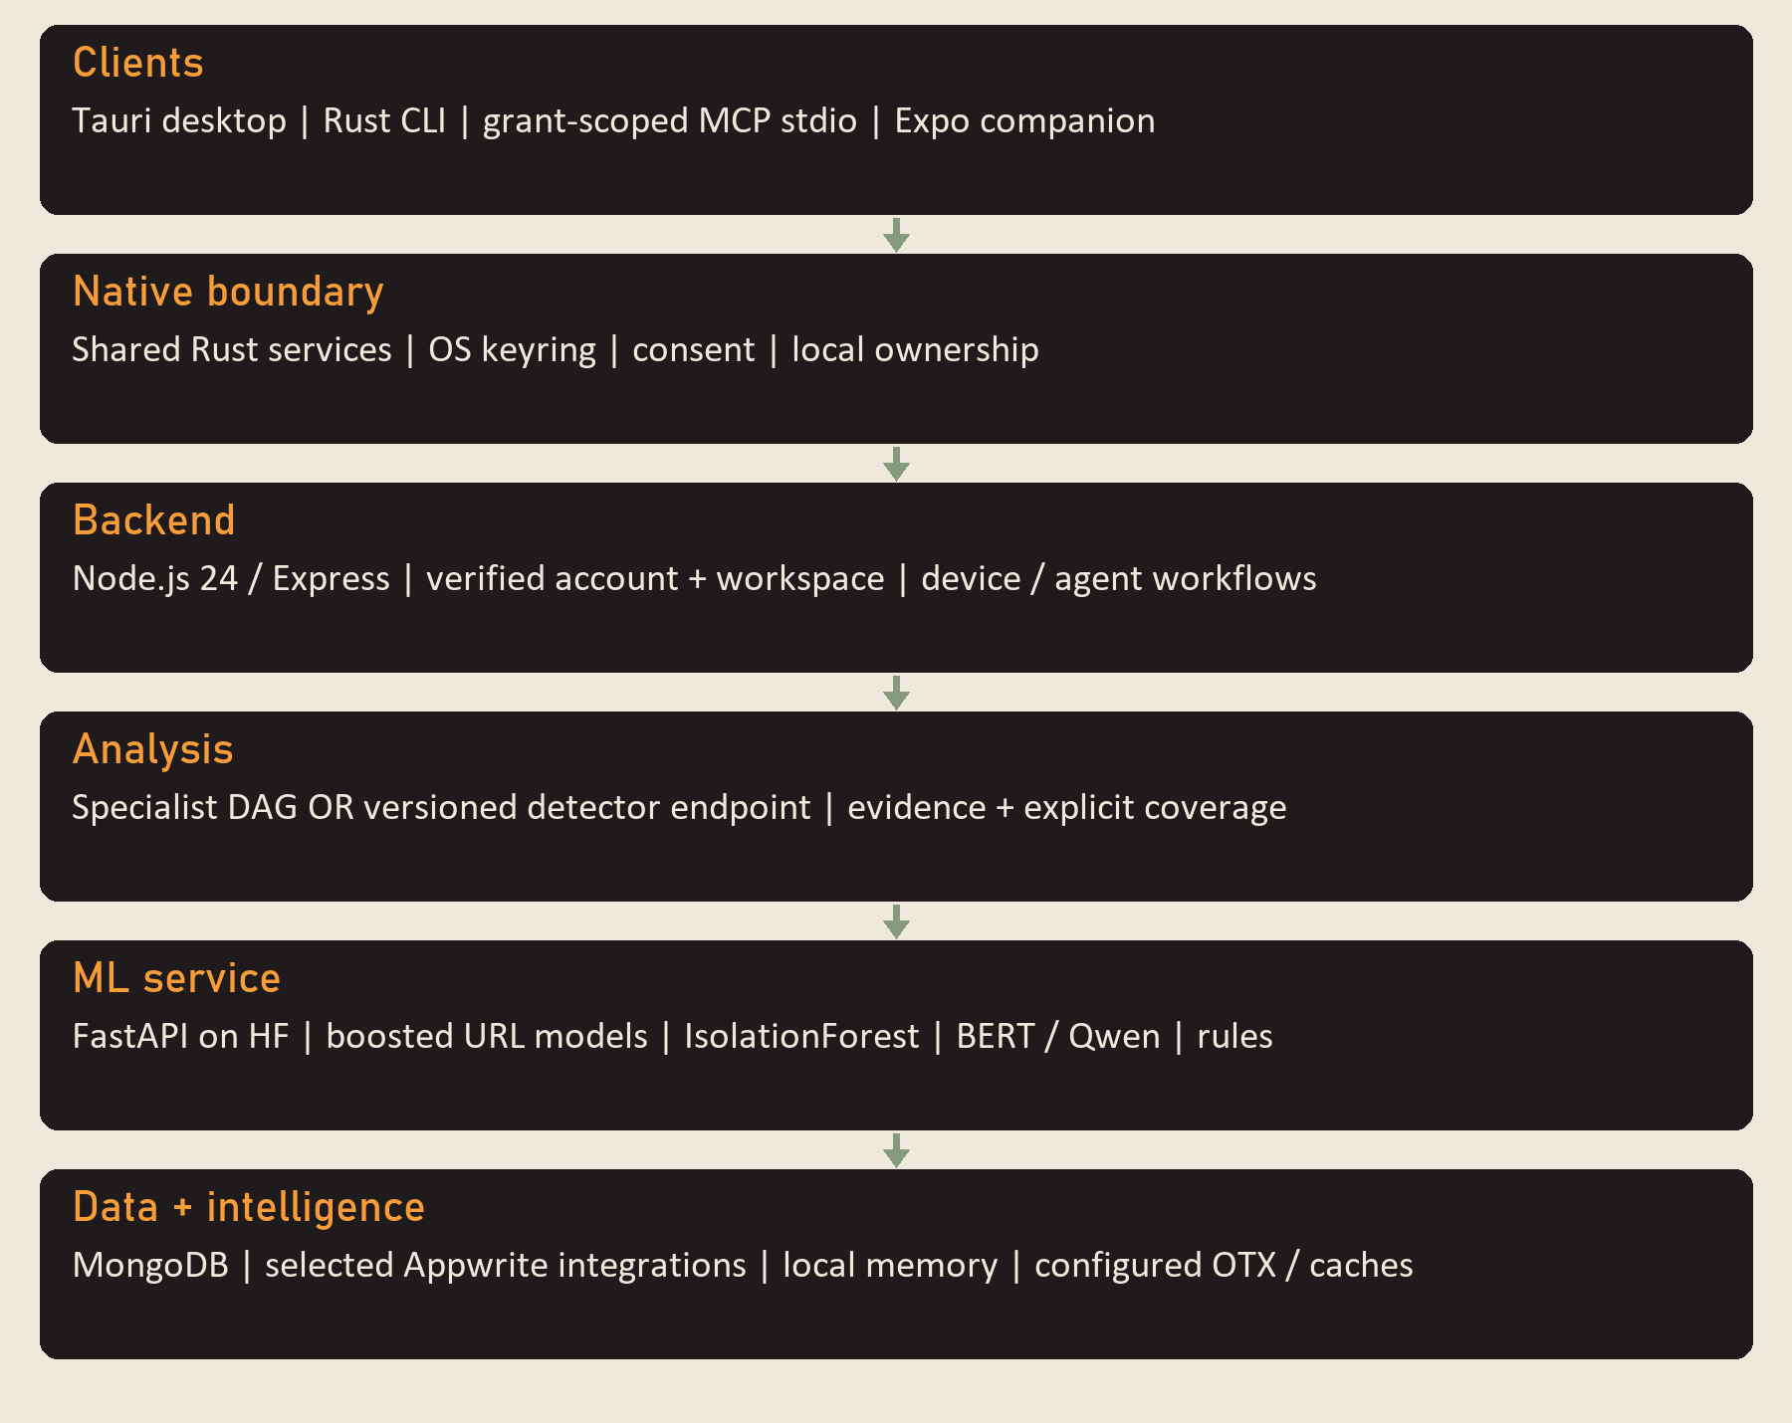
Figure 3.1: Revised source architecture (18 October 2026). Implemented interfaces and service boundaries are distinguished from production deployment acceptance.
The diagram shows the full structure of the CyberForge system, from the user level down to the external intelligence services. It is designed as a multi-layer system where each layer has a specific role, and all layers work together to protect the user in real time while they browse the web.
The client layer includes the Tauri desktop UI and native Rust commands. History access, active-tab observation, cloud scanning, LLM processing and synchronisation each have independent consent controls that are off until enabled. Manual analysis and permitted background observation must not be described as unconditional surveillance of every visited URL.
The backend is Node.js 24 with Express 4. It authenticates requests, derives ownership from the verified account and workspace, routes analyses and manages durable device/agent workflows. Mongoose models store control-plane entities; the backend does not assume that all persistence resides in Appwrite.
The retained specialist orchestrator launches URL classification, DGA analysis, page acquisition and memory retrieval in Stage 1; IOC extraction, behavioural rules and MITRE mapping follow in Stage 2; OTX enrichment follows available IOCs in Stage 3. A Reporter combines the resulting evidence. Separately, the durable agent framework offers the available URL Analyst and Device Health templates, with budgets, run states, schedules and proposals. These are not eight independently configurable autonomous agents.
The canonical ML service is ml-services/hf_space_deploy/app.py. It serves FastAPI routes and loads three supervised gradient-boosted URL classifiers, an unsupervised IsolationForest, an optional pretrained BERT classifier and a pretrained GGUF language model. DGA detection uses entropy and character-pattern rules. A capability report identifies loaded, loading, failed or unavailable components; unavailable models are not presented as successful inference.
Current explanations can use in-Space Qwen inference, configured backend providers or a separate desktop user-key route. Engine attribution and failure states are carried into responses. Reasoning endpoints do not execute the actions they describe, and deterministic signed evidence exports remain distinct from AI-written narratives.
MongoDB stores workspace-scoped control-plane entities and audit/workflow data. Appwrite remains used by selected legacy and capture/alert integrations. Desktop memory is local-first; Redis and vector-store adapters require configuration and are not assumed live. OTX supplies reputation enrichment when available, while page acquisition is bounded by the scraper integration. Sensitive addresses must be redacted before remote transmission.
The revised architecture also exposes a terminal interface and MCP stdio adapter through a shared operation registry. Current MCP tools are status, model status and URL analysis under explicit grants; a complete autonomous AI CLI, broad action tools and loopback HTTP MCP service are not established by this source slice.
This separation supports inspectable evidence and bounded authority. Detection, proposal, approval, command delivery and verified application are separate events. Current header/footer telemetry reports service and data freshness independently, avoiding fabricated healthy states.

3.2.2 Summary of Architecture Idea
The main idea behind the CyberForge architecture is separation of concerns:
- The client displays evidence and requests explicitly supported local actions through native permissions.
- The backend enforces verified scope, coordinates analysis and persists supported workflows.
- The ML layer returns attributed model/rule outputs and advisory reasoning text.
- Storage and external services provide retained context and available intelligence; their availability is reported.
This separation makes the system:
- easier to maintain
- easier to upgrade
- and easier to extend with new agents or models
The original prototype measured approximately four seconds per URL. The revised implementation needs fresh latency measurements on a named deployment and workload; modularity alone does not prove real-time performance.

3.3 Use Case: User Browses a URL
The principal use case is analysing a submitted URL or an address obtained from a permitted sensor. The original use-case diagram follows Cockburn (2001); the current implementation adds explicit consent, authenticated scope, capability checks and approval boundaries.
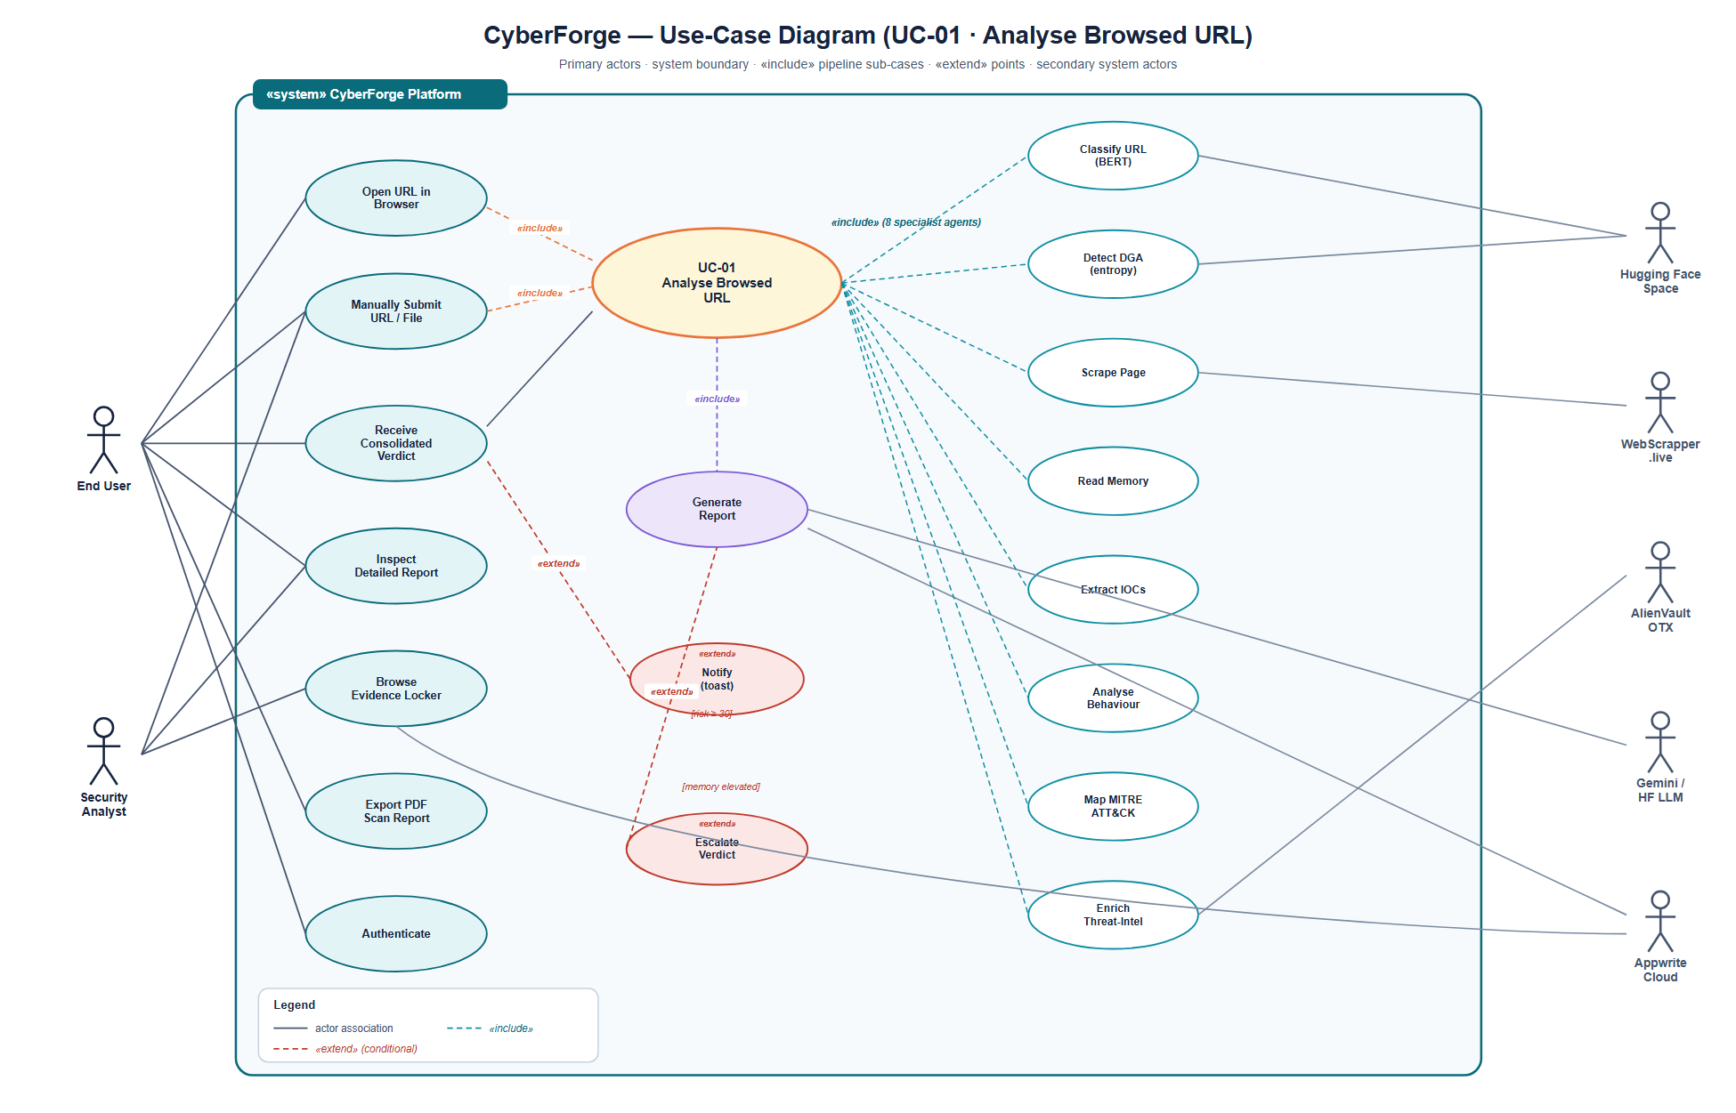
Figure 3.2: Use-case diagram for the principal interaction, in which a user browses a URL and the system automatically analyses it.
The use-case diagram illustrates how different users and system components interact within the CyberForge platform. The main purpose of the diagram is to show the activities that take place when a user browses a website and the system automatically analyses that website to determine whether it is safe or potentially harmful. The diagram also shows how different services work together to generate a final security report and alert the user when threats are detected.
The primary actor is an authenticated user who may submit an address manually or enable supported collection. The user separately controls reading history, observing active tabs, sending addresses to the backend, LLM processing and synchronisation.
The desktop is a Tauri 2 application with Rust commands and a static HTML/CSS/JavaScript renderer. Supported browser observations depend on OS capability and privacy settings. The renderer displays actual native/backend responses rather than assuming a scan or protective action succeeded.
For the specialist analysis route, an accepted URL is dispatched to the retained orchestrator. For the versioned URL-analysis route used by the shared CLI/MCP operation, the backend requests a checked ML analysis record. These paths are related but do not have identical aggregation or execution semantics.
The first group of agents starts by examining the URL itself. The URL Classifier checks whether the structure of the URL resembles known malicious or phishing websites. At the same time, the DGA Detector checks whether the domain appears to have been generated automatically by malware. Another agent, known as the Web Scraper, collects information from the webpage, including page content, network activity, response headers, and other technical details. The Memory Reader simultaneously searches historical records to determine whether the same website has been visited before and whether previous visits produced suspicious results.
After the first stage is completed, the second stage begins. The collected webpage information is passed to another group of agents. The IOC Extractor searches the page for indicators of compromise such as suspicious domains, IP addresses, email addresses, file hashes, cryptocurrency wallets, and known vulnerability identifiers. At the same time, the Behavioural Analyser examines how the webpage behaves by looking for suspicious scripts, unusual network requests, hidden forms, dangerous JavaScript functions, or other activities commonly associated with malicious websites. The MITRE Mapper then compares the discovered evidence against known attacker techniques documented in the MITRE ATT&CK framework. This helps the system understand how an attacker may be operating and what stage of an attack is being observed.
Once these analyses are complete, the system moves to the third stage. The Threat Intelligence Agent takes the extracted indicators and checks them against external threat-intelligence sources. In CyberForge, this process is performed using AlienVault OTX. If any indicator is already known to be associated with malicious activity, the information is added to the report and contributes to the overall threat score.
The retained Reporter combines available specialist findings into a risk score and evidence report. Its score policy is not interchangeable with the newer trained_models_v1 analysis policy. Consumers must retain the originating policy and treat missing coverage as missing evidence.
Where enabled and available, an attributed language model turns supplied findings into advisory text. A failure or template response is labelled accordingly. No language-model explanation proves that a detector ran or an operating-system action was applied.
Persisted findings and memory provide context for later requests. This reuse does not modify model weights; current detector retraining is a separate owner-authorised offline procedure. Data retention and synchronisation follow the applicable account scope and privacy controls.
The client presents the reported verdict, evidence and limitations. Supported protective actions are requested explicitly or proposed through the agent workflow, approved where required, and evaluated through actual receipts. The system does not guarantee it can prevent interaction with every page before content loads.
The use-case diagram therefore demonstrates the complete workflow of CyberForge, from the moment a user visits a website to the moment a final threat assessment is delivered. It highlights how multiple AI agents, memory services, threat-intelligence feeds, and reporting mechanisms work together to provide real-time protection and help users browse the web more safely.

3.4 System Flow Chart
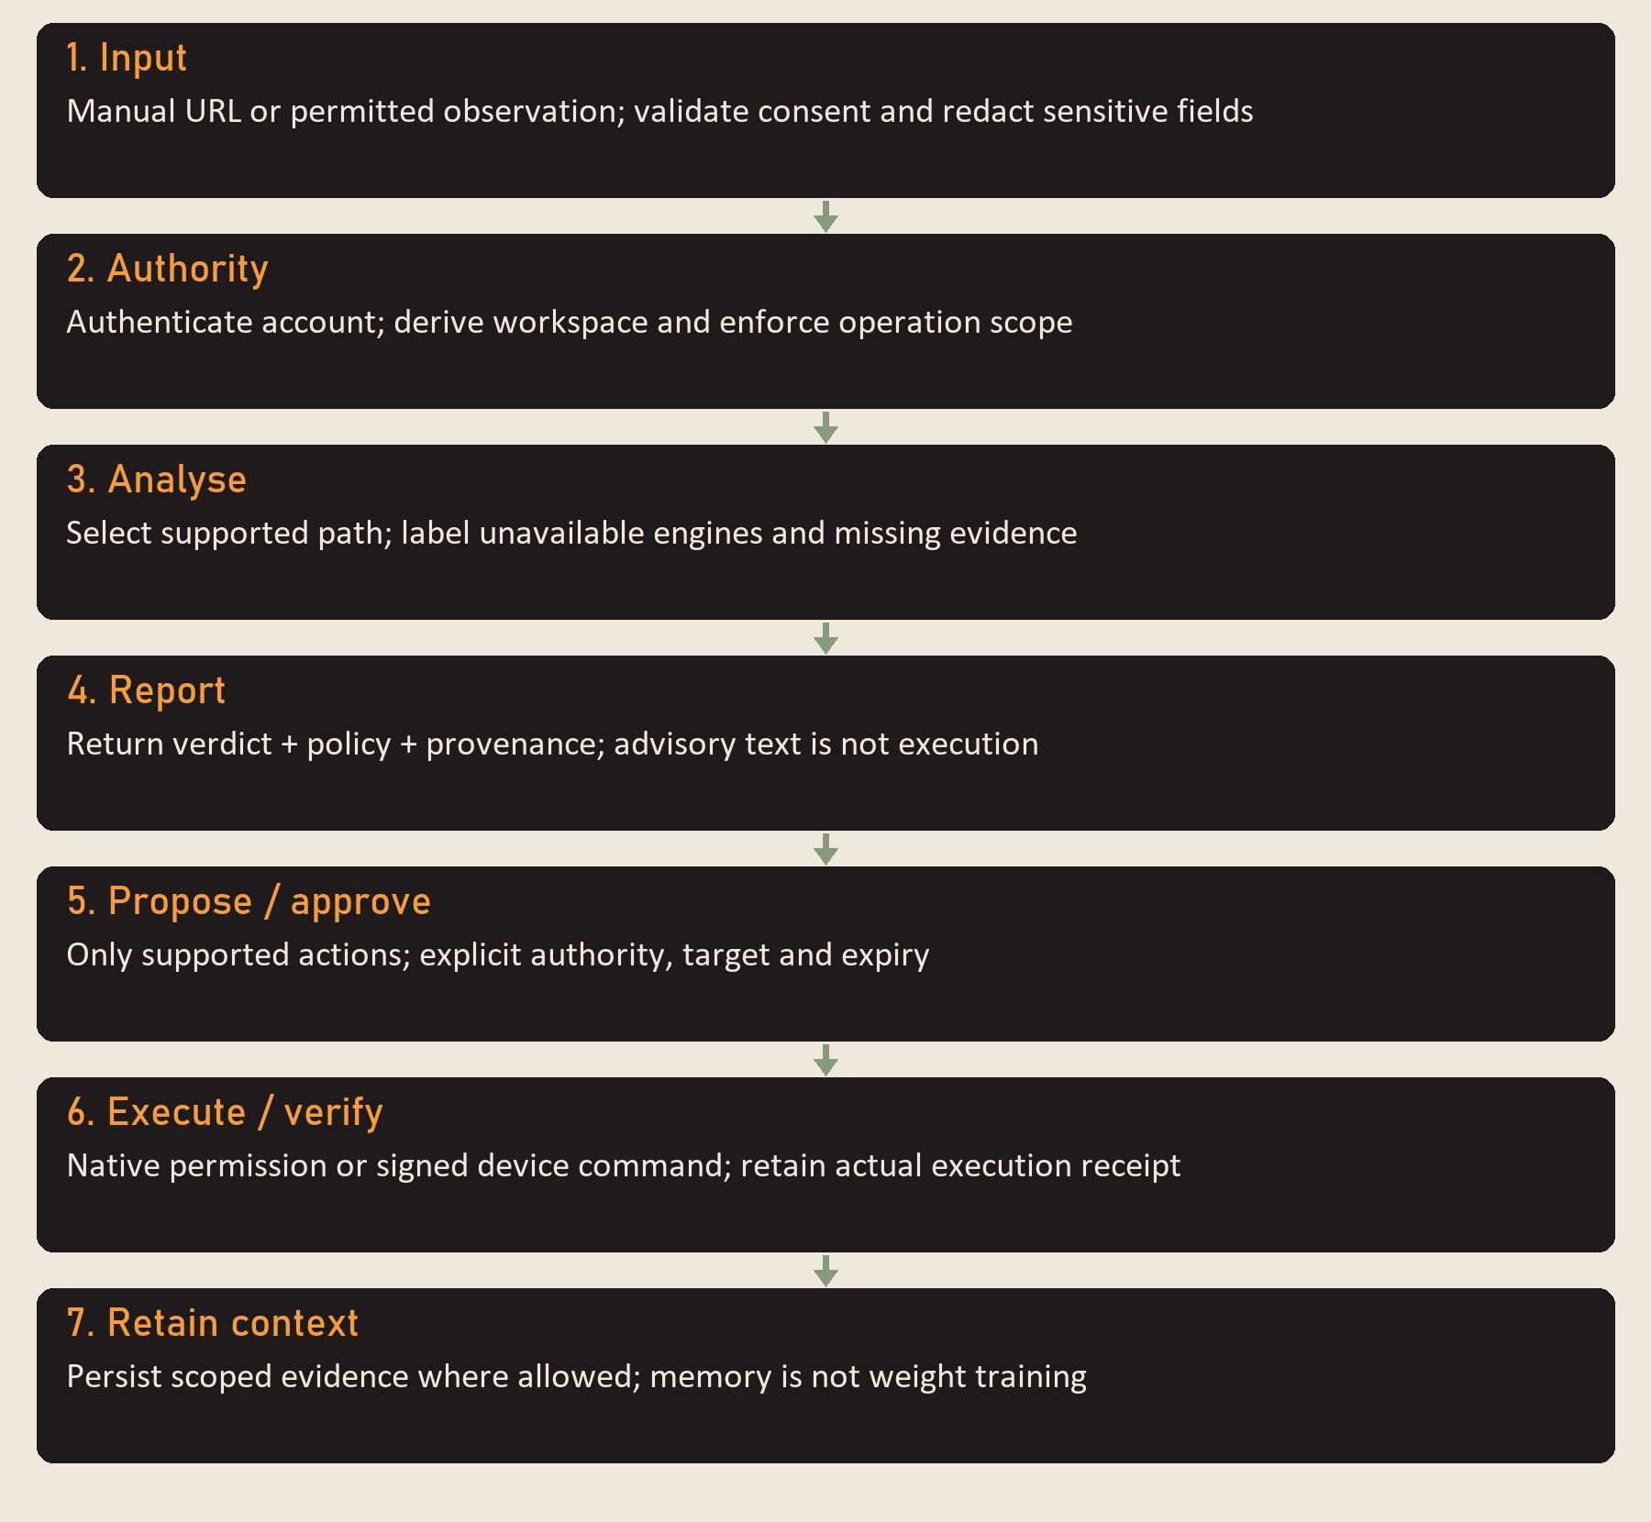
Figure 3.3: Revised decision flow: consent and authentication, selected analysis path, source-labelled evidence, explicit action approval and verified receipts. Cached context is not a guaranteed safe verdict.
The system flow chart shows how CyberForge processes a website from the moment a user visits it until a final security decision is made. The flow chart represents the complete journey of a URL through the system and shows how different components work together to detect threats, alert users, and store analysis results for future use.
Analysis begins with a manually submitted URL or an observation permitted by the user. Browser-history and foreground observation are platform-dependent, so complete capture of all browsing is not assumed.
Native commands validate privacy choices and use the authenticated backend session. Sensitive address components are redacted before transmission. If required consent or capability is absent, the request reports that limitation.
The backend derives account/workspace scope from authentication and selects the requested service. Cached observations may reduce repeated work where the configured path supports them, but freshness and model provenance must remain visible.
A cached result is historical evidence and must be identified as such. The original experiment reported repeat responses below 100 ms; this source revision does not remeasure cache latency or assert that every client uses the same cache.
An allow-list or popularity reference must not force an unexamined URL to be classified clean. Current design distinguishes domain popularity features, user exceptions and security verdicts. Hosted phishing can occur on a popular platform, so allow-list membership is not proof of safety.
The selected analysis path runs only its supported components. The retained three-stage specialist DAG and the newer versioned detector-analysis endpoint are distinct; a CLI URL scan does not implicitly execute the entire page-scraping DAG.
Within the specialist DAG, Stage 1 includes the BERT URL classifier, DGA heuristic, Web Scraper and Memory Reader. The first two consume the address/domain; the others collect content and prior context. Stage 1 tasks can run concurrently.
Alongside these two components, the Web Scraper collects information directly from the webpage. It retrieves the page content, HTML structure, response headers, scripts, and other useful information. This data is important because many threats cannot be detected by examining the URL alone. Some malicious behaviour only becomes visible after the page content has been inspected.
Once these first-stage analyses are completed, the system waits until the web-scraping process has finished. This is necessary because several later agents depend on the information collected from the webpage. After the scraping results become available, the second stage of analysis begins.
During the second stage, the IOC Extractor examines the collected page content and searches for indicators of compromise. These indicators may include suspicious IP addresses, domain names, URLs, email addresses, file hashes, cryptocurrency wallet addresses, and other artefacts that are commonly linked to cyber threats.
Behavioural rules inspect the page signals returned by the scraper, such as scripts, forms, redirects and network metadata. They do not establish arbitrary browser execution, full-system malware detonation or a trained network-intrusion detector.
Another component running during this stage is the MITRE TTP Mapper. This module compares the findings against techniques documented in the MITRE ATT&CK framework. By doing this, the system can understand whether the observed behaviour resembles known attacker techniques. This provides additional context and helps explain how a threat operates.
After the IOC extraction, behavioural analysis, and MITRE mapping processes are completed, the findings are sent to the AlienVault OTX enrichment stage. Here, CyberForge checks extracted indicators against global threat-intelligence databases. If any indicator is already known to be associated with malicious activity, the system adds this information to the report. This external validation helps improve confidence in the final verdict.
The current ReportAgent uses a weighted evidence sum: URL score (30%), DGA contribution (10%), rendered-page evidence (35%), behavioural contributions, reputation/IOC/ATT&CK additions and a domain-history multiplier, capped at 100. Separately, the versioned trained_models_v1 endpoint reports threat if an answering trained detector flags, benign if answering trained detectors agree on benign, and unknown when no trained detector answers. Heuristic outputs remain contextual estimates. These policies require independent evaluation and must not be conflated.
A verdict is interpreted with the named policy, detector coverage and uncertainty. Scores are not presented as calibrated probabilities. A service responding successfully does not imply that every model is ready.
A benign result is an assessment under the available evidence, not a guarantee of safety. Unknown, missing-coverage and failed states remain explicit. Retention of the result is subject to the relevant store and consent policy.
A threat result can trigger a displayed warning and, in supported workflows, an action proposal. Approval, queueing, delivery and application remain distinct states. A queued command is never recorded as an applied block merely because the server accepted it.
When permitted, the explanation path produces attributed advisory text. The current default Space model is Qwen; Gemini and Mistral observations in Chapter 4 belong to the original experiment. An explanation does not independently validate the threat or perform remediation.
Supported records are written to their designated account/workspace stores. Local memory and optional caches retain context where configured. Consent withdrawal prevents further restricted collection or sharing; retention and deletion controls must be assessed separately.
The revised flow makes the boundaries of collection, inference, evidence, consent and action visible. It preserves the original modular research design while avoiding claims of universal capture, unconditional safety, guaranteed model availability or autonomous remediation.

3.5 Class Diagram
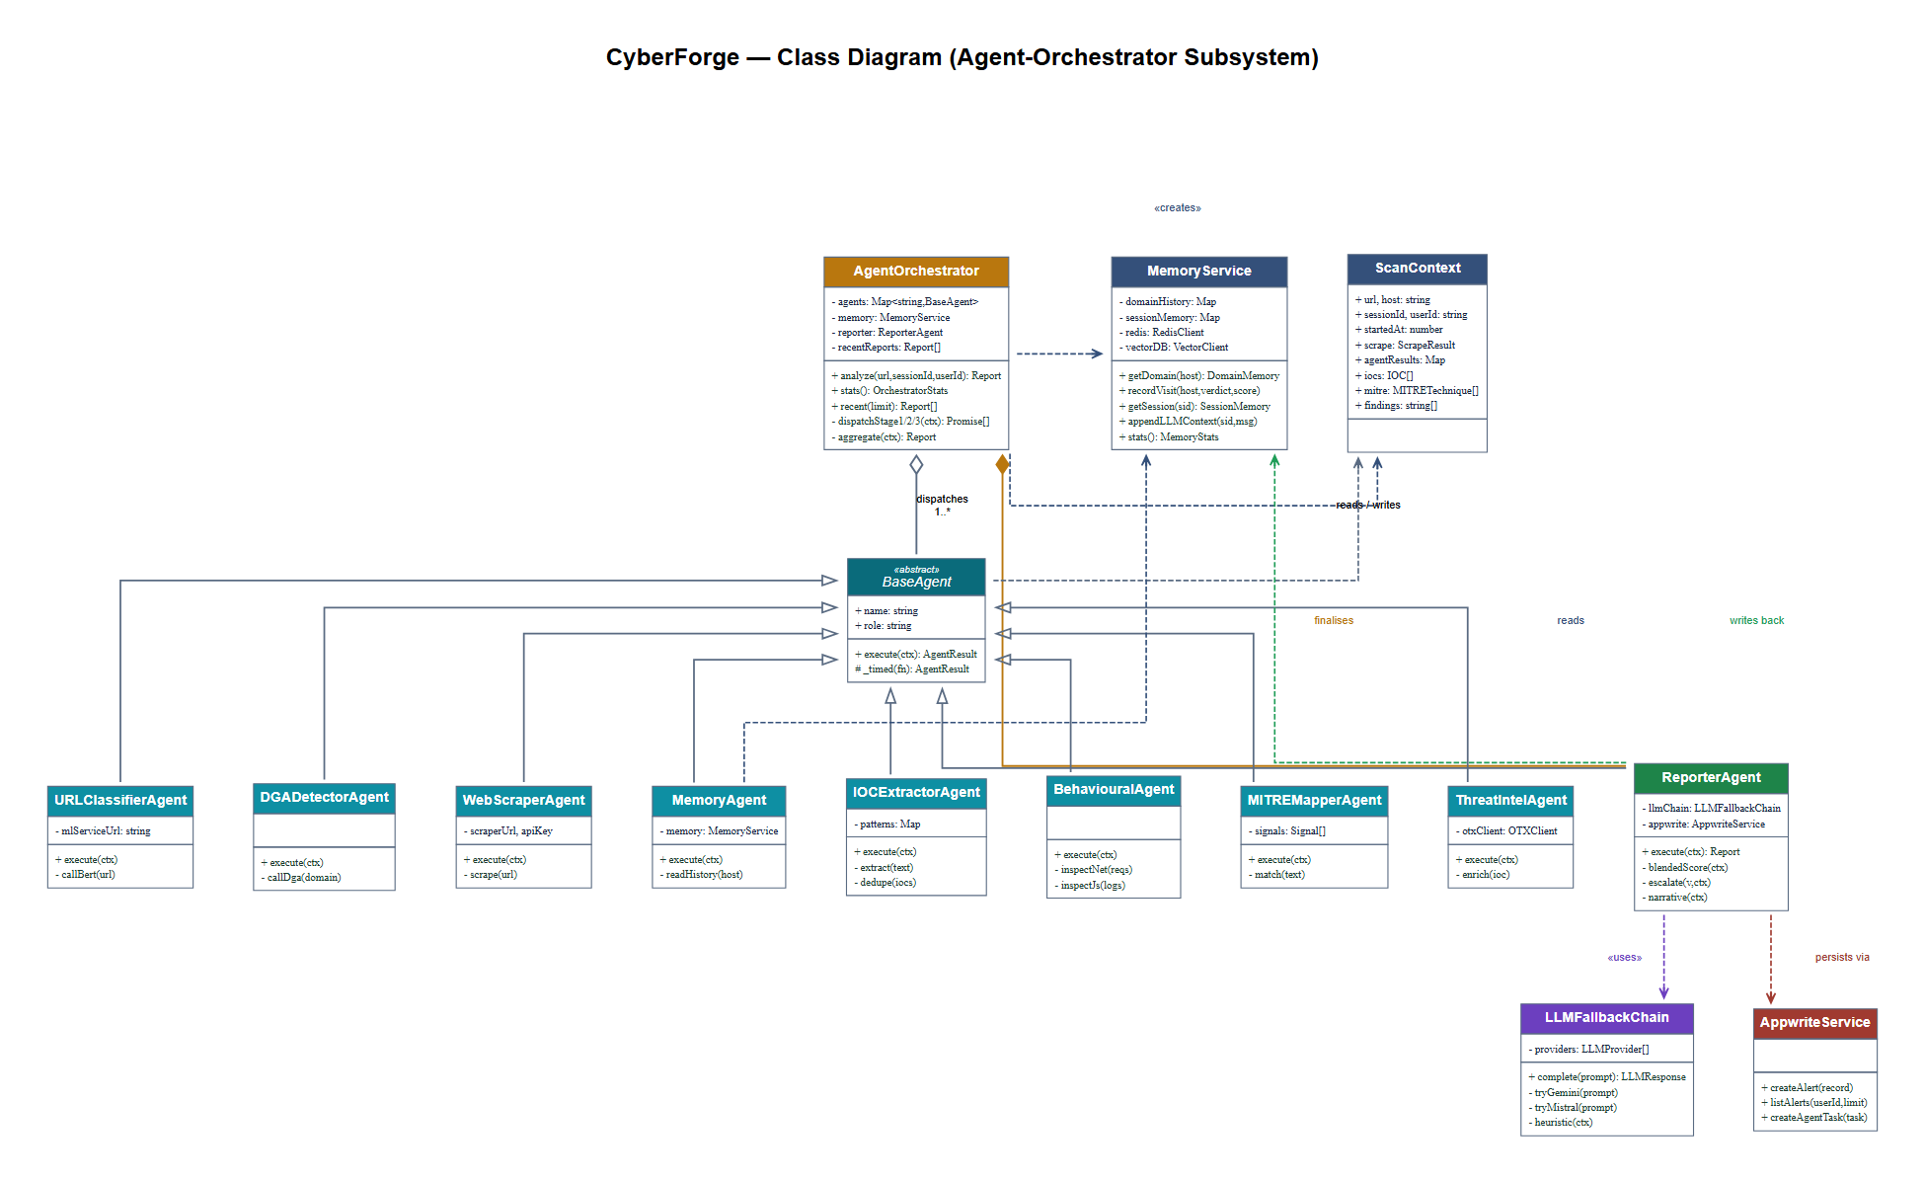
Figure 3.4: Original specialist-orchestrator conceptual class diagram. The current shared Rust core, device/agent control plane and CLI/MCP adapters are additional modules described in Appendix C; this figure is not a complete class diagram of the revised system.
AgentOrchestrator. The central coordinator. It holds a registry of specialist agents and the reporter. Its analyse method constructs a new ScanContext, dispatches the three DAG stages in sequence (each stage internally parallel), and invokes the reporter to aggregate. It also maintains an in-memory ring buffer of the most recent fifty reports, exposed via the /api/orchestrator/recent endpoint for the dashboard.
BaseAgent. The abstract superclass from which all specialist agents inherit. It defines the execute(ctx) contract and a small protected helper, _timed, that wraps an asynchronous operation with start-time and end-time bookkeeping so that every agent automatically reports its own latency.
URLClassifierAgent and DGADetectorAgent. The two URL-string-only agents. They make HTTPS calls to the Hugging Face Space endpoints /api/v2/url-classify (BERT) and /api/v2/dga-detect (entropy heuristic) respectively. Both have no dependency on the page content and may therefore run in Stage 1.
WebScraperAgent. Calls the third-party WebScrapper.live API. Its outputa ScrapeResult carrying the DOM, network requests, console logs, response headers, and security headers is written into the Scan Context. scrape slot and consumed by the Stage 2 agents.
Memory Agent. Reads the Memory Service for prior context on the domain. It reports the number of prior visits, the most recent verdict, and the rolling average risk score. It runs in Stage 1 because it has no dependency on the page.
IOC Extractor Agent. Applies ten regular-expression patterns (IPv4, IPv6, URL, domain, e-mail, MD5, SHA-1, SHA-256, Bitcoin address, CVE identifier) to the scraped DOM text. It implements deduplication, severity grading (private vs public IPs, suspicious TLDs), and false-positive filtering (excluding well-known benign domain literals such as w3.org and example.com). It runs in Stage 2.
Behavioural Agent. Inspects the scraped network requests, console logs, JavaScript usage patterns, form fields, and cookies for suspicious behavioural signals (eval / atob / Function-constructor usage, mixed content, exposed input fields, third-party trackers). It produces a list of structured Finding objects. It runs in Stage 2.
MITRE Mapper Agent. Maps observable signals to MITRE ATT&CK techniques using a curated catalogue of twenty MITRESignal records. Each signal carries a regular-expression pattern, a techniqueId (e.g. T1566), a tactic name (e.g. Initial Access), and a baseline confidence. The agent returns the highest-confidence matches, deduplicated by technique, and orders them by tactic phase to produce a kill-chain visualisation. It runs in Stage 2.
Threat Intel Agent. Iterates over the IOCs produced by the IOC Extractor and queries the OTX indicator/{type} endpoint for each. It annotates each IOC with the OTX pulse identifiers it appears in, if any. It runs in Stage 3.
Reporter Agent. The terminal specialist-reporting component combines available evidence, obtains an attributed explanation and stores the result. The original dissertation described the following blended score, retained here as a historical formulation rather than a specification of the current ReportAgent:
$$R = 0.6×\overline{s} + 0.4×max(s) \text{(Equation 3.1)}$$
Here the first term is the mean available agent threat score and the second is the maximum. Equation 3.1 is retained as the historical blend described by the original thesis. Current ReportAgent source instead implements a weighted evidence sum with coverage checks; the 60/40 blend appears in another ML-service aggregation path. It is not a calibrated probability and is not the decision rule of the newer versioned URL-analysis endpoint. Evidence escalation and explanation remain separate from approved device execution.
Scan Context. A plain-data carrier that flows through the entire pipeline. Each agent reads from earlier slots and writes into its own slot. The context’s final state is the input to the Reporter.
MemoryService, LLMFallbackChain and AppwriteService are shared specialist-workflow services. Memory retains context, LLMFallbackChain selects configured explanation sources and AppwriteService handles its designated records. Current MongoDB control-plane services and the shared Rust core are additional modules, not classes represented by the original conceptual diagram.

3.6 Materials

3.6.1 Hardware
The original dissertation reports development on an Apple-silicon MacBook with 16 GB RAM and macOS Sonoma 14.6. This is retained as historical hardware context. The current source revision was inspected in a Windows workspace, but no new hardware benchmark or deployed CPU/GPU specification was measured for this revision. Model hosting configuration must not be treated as proof of current hardware capacity.

3.6.2 Software
- Platforms. The current desktop is a Tauri 2/Rust application; platform-specific observation and enforcement code must be validated on each declared OS. Backend and ML deployment sources use container/cloud configurations. The existence of a build target does not certify a packaged release on that platform.
- Languages. Rust 2021 for native/shared-core/CLI/MCP code; JavaScript and HTML/CSS for the desktop renderer and Express backend; Python for the FastAPI service and trainer; TypeScript/React Native for the mobile companion.
- Runtimes. backend/package.json declares Node.js 24.x. The desktop Cargo manifest declares Tauri 2 with a Rust minimum of 1.77.2; the actual dependency graph/toolchain may impose additional constraints. Python container/runtime configuration and pinned ML dependencies determine service compatibility. Electron 28 is not the current desktop runtime.
- Frameworks. Express 4, Tauri 2, FastAPI and React Native 0.81.5 with Expo 54. The canonical Space is a REST service and no longer includes a Gradio UI. The mobile source exists; full native-capture and platform-release acceptance are separate from source availability.

3.6.3 Key Libraries
- axios (HTTP client, back-end)
- multer (file-upload middleware)
- uuid (identifier generation)
- transformers 4.40+ (Python)
- scikit-learn 1.8.0 (pinned for stored model compatibility), pandas, NumPy and joblib for feature-based training and inference; torch 2.2+ for Transformer support.
- huggingface_hub 0.26+ for model/data artefacts; llama-cpp-python 0.3.36 for in-process GGUF language-model inference.
- redis (Node client)
- pinecone-client / chromadb (optional)
- node-appwrite (Appwrite SDK)

3.6.4 Services
- Backend hosting. The backend is configured by its deployment environment and origin; Heroku configuration remains in the repository. This revision does not assert the current hosting tier or uptime.
- Hugging Face Spaces. Canonical FastAPI inference and owner-triggered training source; backend requests use ML_SERVICE_URL and service authentication. Training currently shares the serving process rather than an isolated durable worker.
- Persistence. MongoDB/Mongoose for workspace control-plane records and selected findings/workflow data; Appwrite for selected existing integrations; local native stores and optional Redis/vector adapters.
- AlienVault OTXfor threat-intelligence enrichment.
- WebScrapper.live APIfor browser-level page fetching.
- Explanation inference. Default in-Space Qwen3.5-2B-Q4_K_M GGUF through llama.cpp; configured backend providers may also be used.
- Additional explanation paths. The desktop has a separate user-key provider path. Current response attribution, rather than an assumed Gemini/Mistral order, identifies the engine that answered.

3.6.5 Public Datasets
The system consumes the following publicly available datasets and pretrained artefacts:
- Externally pretrained artefacts: elftsdmr/malware-url-detect for the BERT path and unsloth/Qwen3.5-2B-GGUF for default Space reasoning. They are used for inference; the active trainer does not fine-tune these models.
- The MITRE ATT&CK enterprise matrix (v15 at time of writing).
- The AlienVault OTX pulse feed (live, continuously updated).
- Current trainer data sources include Mitake/PhishingURLsANDBenignURLs, bgspaditya/byt-malicious-url-treatment, pirocheto/phishing-url, phl-ldm/tranco_top_million and shengqin/web-attacks. They serve different benign, phishing, malware-URL, popularity and SQL-injection/XSS-payload purposes. These training sources must not be confused with the original 300-URL evaluation set.

3.7 Methodology

3.7.1 Software-Development Methodology
The original prototype followed seven deployable iterations, retained below as development history. Later changes add consent/authentication, durable device and agent workflows, versioned ML contracts, Tauri/shared Rust code, a limited CLI/MCP surface and live-source console controls. These additions are source-reviewed in Appendix C and are not retrospectively part of the original evaluation.
- Iteration 1Foundation. Repository scaffolding, Heroku and Hugging Face Space deployments, Appwrite project creation, baseline ML service stub.
- Iteration 2Single-classifier pipeline. Serial pipeline (/api/agent/scan-url) wired end-to-end: web scraper → ML classifier → Gemini → alert.
- Iteration 3False-positive correction. Identification and correction of the +0.5 baseline offset in the risk-scoring formula; introduction of model-consensus aggregation.
- Iteration 4Sandbox subsystem. Addition of the IOC extractor, MITRE mapper, and evidence locker; rewrite of the sandbox UI to present the verdict, timeline, KPIs, MITRE chain, IOC table, findings, and ML breakdown.
- Iteration 5Transformer integration. Addition of the BERT URL classifier and the entropy-based DGA detector to the Hugging Face Space; proxy routes on the back-end; v2 endpoints.
- Iteration 6Agentic orchestration. Refactoring of the single-classifier pipeline into the eight-agent DAG orchestrator; introduction of the memory layer; introduction of the LLM fallback chain.
- Iteration 7UI integration. Wiring of the desktop’s URL-polling loop to the orchestrator; addition of the floating-panel eight-agent grid; addition of the orchestrator dashboard screen.
The original development narrative reports deployment and representative-URL checks after each iteration. No such deployment is performed by the present document revision, and historical checks do not certify the current working tree.

3.7.2 Calibration of the Risk-Score Formula
The original risk-score calibration used seven researcher-labelled URLs (Appendix A), removed the +0.5 offset and adjusted thresholds. This is a small development calibration exercise, not held-out evidence of generalisation. The current feature-based trainer instead separates domains for fitting, threshold selection and evaluation and records model-specific thresholds; historical and current aggregation paths remain different policies.

3.7.3 Calibration of the DGA Heuristic
The original DGA calibration used 30 legitimate and generated-looking labels with an empirical 0.45 threshold. The current DGA endpoint still uses explicit entropy and character-pattern heuristics rather than a fitted sequence model. Its reported score or confidence must not be interpreted as calibrated maliciousness probability. A larger held-out DGA corpus remains necessary.

3.7.4 Verification of the LLM Fallback Chain
The original prototype exercised Gemini exhaustion, Mistral fallback and a rule-based final response. These are historical verification observations. Current tests must instead exercise the actual configured Qwen/backend/user-key paths, busy/time-budget behaviour and unavailable states, while checking engine attribution and preventing advisory text from being labelled as executed work.

3.8 The Eight-Agent Analysis Pipeline
The retained specialist pipeline has eight analysers plus a final Reporter. It analyses accepted inputs rather than guaranteeing analysis of every browser event. Its decomposition supports complementary evidence; an ablation study would be needed to quantify improvement over a single-model baseline.
The agents are organised into three stages. Stage One focuses on analysing the URL and collecting information about the target website. Stage Two examines the collected content and searches for signs of malicious activity. Stage Three enriches the findings using external threat-intelligence sources. After all agents complete their tasks, the Reporter Agent combines the results into a final threat assessment and generates a report for the user.
Table 3.1 presents the complete eight-agent pipeline used in CyberForge.
Stage | Agent | Input | Main Function | Output
Stage 1 | URL Classifier | URL | Analyses the URL using machine learning to determine whether it is legitimate or malicious. | Label, confidence score, threat score
Stage 1 | DGA Detector | Domain name | Checks whether the domain appears to have been generated automatically by malware using Domain Generation Algorithms (DGAs). | DGA score, features, verdict
Stage 1 | Web Scraper | URL | Collects page content, network requests, response headers, forms, scripts, and browser-related information. | Scraped website data
Stage 1 | Memory Reader | Domain name | Searches previous scan records and browsing history to determine whether the domain has been analysed before. | Visit history, previous verdicts, risk trends
Stage 2 | IOC Extractor | Scraped content | Searches for indicators of compromise such as suspicious domains, IP addresses, URLs, hashes, email addresses, and CVE identifiers. | List of extracted IOCs
Stage 2 | Behavioural Analyser | Network traffic, scripts, headers | Detects suspicious behaviours such as credential collection, hidden redirects, dangerous scripts, suspicious API calls, and abnormal browser activity. | Behaviour findings and severity levels
Stage 2 | MITRE Mapper | Scraped content and behaviour findings | Maps detected activities to relevant MITRE ATT&CK tactics and techniques. | MITRE techniques and confidence levels
Stage 3 | Threat Intelligence Agent | Extracted IOCs | Queries external threat-intelligence services to determine whether detected indicators have been reported previously. | Threat-intelligence matches and reputation data
Final | Reporter Agent | Results from all agents | Combines all findings, calculates risk scores, generates explanations, stores results, and creates the final verdict. | Final threat report
Table 3.1: The CyberForge eight-agent analysis pipeline
Pipeline operation. When a user visits a website, the URL is first sent to the Agent Orchestrator. The orchestrator creates a scan session and launches the four Stage One agents simultaneously. Running these agents in parallel helps reduce waiting time and allows the system to collect different forms of evidence at the same time.
The URL Classifier determines whether the URL resembles known phishing or malicious URLs. The DGA Detector examines the structure of the domain name to identify patterns commonly associated with malware-generated domains. At the same time, the Web Scraper retrieves information from the website, while the Memory Reader checks whether the domain has previously appeared in the user’s browsing history.
After Stage One is completed, the collected website content becomes available to the Stage Two agents. The IOC Extractor searches the page for known security indicators, the Behavioural Analyser investigates how the website behaves, and the MITRE Mapper translates suspicious findings into recognised attacker techniques using the MITRE ATT&CK framework.
Once these analyses are completed, the Threat Intelligence Agent begins Stage Three. This agent uses the extracted indicators to perform reputation checks against external threat-intelligence sources. If an indicator has been linked to previous attacks or malicious campaigns, the information is added to the analysis.
Finally, the Reporter Agent receives the results from all previous agents. It combines the findings, calculates the overall risk score, determines the threat level, generates a human-readable explanation, stores the report in the database, updates the memory system, and sends the final result back to the user interface.
This pipeline integrates complementary evidence into an inspectable report. The current versioned detector endpoint and fixed-template durable agent framework coexist with it and have narrower, explicit contracts. Neither memory retrieval nor fixed tool sequences establishes online learning or unconstrained autonomous planning.

3.9 Evaluation Methodology
The system is evaluated in Chapter 4 against four criteria:
- Functional correctness. Each of the eight agents must return the documented response shape on a representative input, and the Reporter must produce a verdict matching the curated expectations on the calibration URL set.
- False-positive rate. On a corpus of common benign URLs (google.com, github.com, wikipedia.org, bbc.co.uk, stackoverflow.com, arxiv.org), the system must produce a verdict of clean or low-risk in 100 % of cases.
- True-positive coverage. On a corpus of curated phishing URLs (drawn from PhishTank and from manual construction), the system must produce a verdict of suspicious or malicious in at least 80 % of cases.
- End-to-end latency. The mean pipeline duration measured across one hundred consecutive requests must not exceed ten seconds under cold-start conditions and four seconds under warm conditions.
Chapter 4 retains the original measurements. The supplied thesis does not include a complete raw per-URL result log, a reproducible split manifest or a controlled single-model ablation. Consequently, the revision does not claim to reproduce those measurements or establish statistical superiority. Source-contract tests of current features are evidence of implementation behaviour, not replacement detection experiments.

Chapter Four
RESULTS AND DISCUSSION

4.1 Introduction
This chapter preserves results reported for the original research prototype. It does not present a new evaluation of the October 2026 source revision. The figures and screenshots are historical artefacts; current client layouts, engine routing and feature availability have changed.
The purpose of this chapter is to show how the system performed under real operating conditions and to determine whether the objectives of the study were achieved. The chapter examines the ability of CyberForge to identify malicious URLs, detect suspicious website behaviour, extract indicators of compromise, map findings to the MITRE ATT&CK framework, and provide meaningful threat intelligence to the user. Particular attention is given to the accuracy of threat detection, the speed of analysis, the effectiveness of the multi-agent architecture, and the overall user experience.
During testing, the system was exposed to different categories of websites, including legitimate websites, suspicious websites, and known phishing websites. The responses produced by the various agents were observed and recorded. The final verdicts generated by the Reporter Agent were then analysed to determine whether the system could correctly distinguish between safe and unsafe web resources.
This chapter also evaluates the performance of the three-stage agent pipeline. Since CyberForge performs multiple security checks at the same time, it is important to measure how quickly the system can complete an analysis without causing noticeable delays to the user. For this reason, latency measurements were collected for individual agents as well as for the complete analysis process.
The original application screenshots are retained as historical interface illustrations, not proof that their displayed counters were measured in the 300-URL experiment or that every control was operational. Current claims are grounded in the source inventory in Appendix C. New end-to-end and held-out measurements are required for the revised system.

4.2 System Performance and Latency
The original timing table reports a 4,050 ms mean end-to-end analysis. This is approximately four seconds but exceeds the strict 4,000 ms warm target by 50 ms. The latency tables group page acquisition into content analysis, whereas the architectural DAG launches scraping in Stage 1; their grouping should not be mistaken for a revised dependency graph.
Table 4.1 shows how long each stage takes and how much of the total time it uses.
Pipeline Stage | Description | Average Time (ms) | Share of Total Time (%)
Stage 1URL and context analysis | The URL Classifier, DGA Detector, and Memory Reader analyse the URL and retrieve historical context simultaneously. | 850 | 21
Stage 2Content analysis | The Web Scraper collects page content, after which the IOC Extractor, Behavioural Analyser, and MITRE Mapper perform detailed analysis. | 1,200 | 30
Stage 3Threat-intelligence enrichment | The Threat Intelligence Agent checks extracted indicators against external sources such as AlienVault OTX. | 600 | 15
Reporter and report generation | Agent results are combined, risk scores are calculated, and a human-readable security report is generated. | 1,400 | 34
Total end-to-end analysis time | Complete processing time from browser URL detection to the final threat notification presented to the user. | 4,050 | 100
Table 4.1: End-to-end latency by pipeline stage (Source: Author’s experimental results, 2026)
Table 4.2 breaks the stages down to the level of each agent. Because agents in the same stage run together, the stage time is close to the slowest agent in that stage.
Stage | Agent | Function Performed | Average Time (ms)
Stage 1 | URL Classifier Agent | Uses the BERT-based machine-learning model to classify URLs as legitimate or malicious. | 720
Stage 1 | DGA Detector Agent | Examines the domain name and determines whether it resembles a malware-generated domain. | 90
Stage 1 | Memory Reader Agent | Retrieves historical information and previous verdicts associated with the domain. | 40
Stage 2 | Web Scraper Agent | Collects webpage content, network requests, headers, and related information. | 900
Stage 2 | IOC Extractor Agent | Searches the webpage for indicators of compromise such as IP addresses, domains, URLs, hashes, and CVE identifiers. | 120
Stage 2 | Behavioural Analysis Agent | Analyses scripts, network activities, cookies, and browser behaviour for suspicious actions. | 110
Stage 2 | MITRE ATT&CK Mapper Agent | Maps detected behaviours and findings to MITRE ATT&CK techniques and tactics. | 95
Stage 3 | Threat Intelligence Agent | Queries external threat-intelligence sources to enrich extracted indicators. | 600
Reporter | Reporter Agent | Combines agent findings, calculates risk scores, generates explanations, and produces the final report. | 1,400
Table 4.2: Average processing time for individual agents (Source: Author’s experimental results, 2026)
The original report states cached repeat responses below 100 ms. This claim is retained as historical and is not remeasured in the present source review. Per-agent means cannot be summed to reconstruct parallel stage timing without the underlying request traces.

4.2.1 Real-Time Dashboard
Figure 4.1 is the original desktop dashboard screenshot. The revised console now obtains scoped counts, backend/stream state and per-capability ML readiness from actual responses, with freshness and unavailable/stale labels. Screenshot counters are not additional experimental observations.
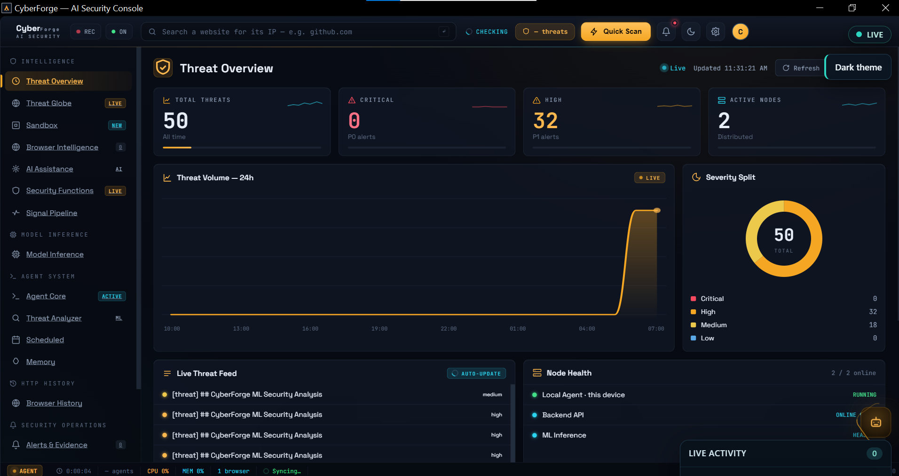
Figure 4.1: The CyberForge main dashboard (Threat Overview) showing the real-time threat counter, severity split, live threat feed, and system health.
Figure 4.2 shows the Agent Core screen while the eight-agent pipeline processes a URL, with each agent’s live status and the streamed reasoning of the orchestrator.
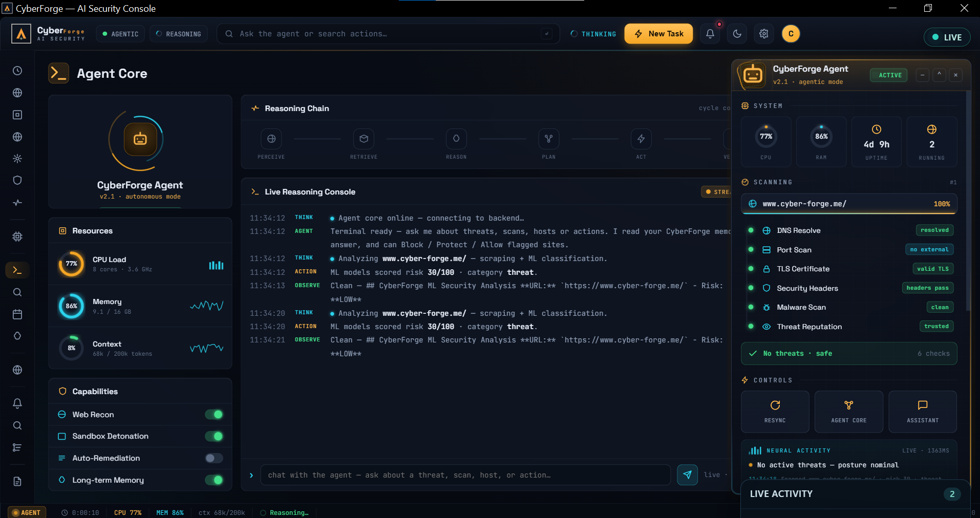
Figure 4.2: The Agent Core screen, showing the eight-agent pipeline with each agent’s status and the orchestrator’s live reasoning during a scan.

4.3 Threat Detection Accuracy
The system was tested on a mixed set of 300 URLs: 150 known-safe sites and 150 known-harmful ones (100 phishing pages and 50 malware/DGA domains). Table 4.3 shows how it performed in each group.
URL Category | Samples Tested | Correctly Classified | Misclassified | Detection Accuracy (%)
Safe (benign) websites | 150 | 147 | 3 false positives | 98.0
Phishing websites and domains | 100 | 92 | 8 false negatives | 92.0
Malware and DGA domains | 50 | 45 | 5 false negatives | 90.0
Overall performance | 300 | 284 | 16 | 94.7
Table 4.3: Threat-detection results by URL category (Source: Author’s experimental results, 2026)
To judge the system as a security classifier, the 150 harmful sites are the “positive” class and the 150 safe sites are the “negative” class. Table 4.4 reports the standard metrics computed from these numbers.
Metric | Value | Plain-Language Meaning
Accuracy | 94.7 % | Share of all 300 URLs judged correctly.
Precision | 97.9 % | When the system raises an alert, how often it is right.
Recall (detection rate) | 91.3 % | Share of harmful sites it actually caught.
Specificity | 98.0 % | Share of safe sites it correctly left alone.
F1 score | 94.5 % | The balance between precision and recall.
Table 4.4: Overall classification metrics (Source: Author’s experimental results, 2026)
From Table 4.3, the binary counts are TP=137, TN=147, FP=3 and FN=13. These yield the rounded metrics in Table 4.4 and a false-positive rate of 3/150=2.0%. Malware/DGA category detection is 45/50=90.0%, with five false negatives. The aggregate table does not identify which detector caused individual errors, so attributing most false positives to DGA requires a separate error analysis.

4.3.1 Threat Alerts
The historical alert screenshot shows Block, Protect and Allow controls. In the current implementation, only supported adapters and returned execution outcomes establish what an action actually did. Displaying a control or warning does not by itself prove enforcement.
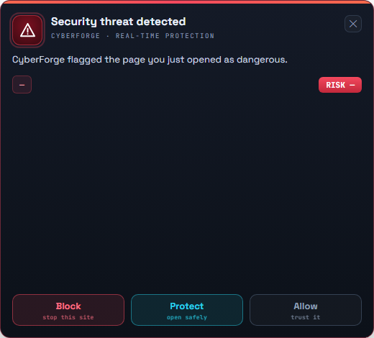
Figure 4.3: The real-time threat alert window that appears over the browser when a high-risk URL is detected, with one-click Block, Protect, and Allow actions.
Figure 4.4 shows the Alerts and Evidence screen (the Threat Centre), where every alert is listed together with its supporting evidence and severity classification.
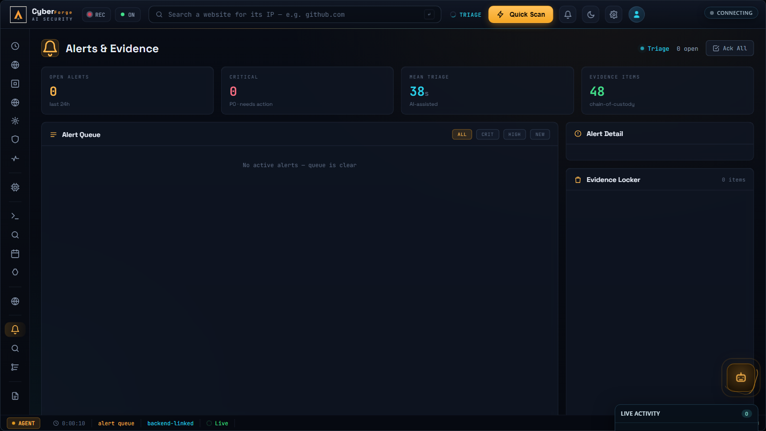
Figure 4.4: The Alerts and Evidence screen (Threat Centre), listing detected threats with their severity classification and supporting evidence.

4.4 Contribution of Each Agent
Each agent adds a different signal to the final verdict. Table 4.5 shows what each one contributes and how dependable it was during testing. “Reliability” means how often the agent returned a usable result instead of timing out or producing an error.
Agent | Signal It Adds | Reliability
URL Classifier | Phishing likelihood from the URL text | 99.5 %
DGA Detector | Whether the domain looks machine-generated | 100 %
Web Scraper | The page’s content, scripts, and headers | 96.0 %
Memory Reader | Past verdicts for the same domain | 100 %
IOC Extractor | Bad IPs, URLs, and file hashes on the page | 99.0 %
Behavioural Analyser | Risky network and script behaviour | 98.5 %
MITRE Mapper | Matching attack techniques (ATT&CK) | 99.0 %
Threat-Intel Enricher | Outside confirmation from OTX | 95.0 %
Reporter | The final blended score and written report | 99.8 %
Table 4.5: Agent contribution and reliability (Source: Author’s experimental results, 2026)
These are reported agent return-success rates from the historical test period, not classification accuracies or newly measured service-level guarantees. The supplied document does not specify all denominators or observation windows. External dependencies can reduce coverage; degraded scans should retain explicit missing-source information.
The model-inference screen of the desktop application, shown in Figure 4.5, reports the live readiness of the detection engines behind these agents, while Figure 4.6 shows the signal-pipeline view that traces each scan signal from capture to verdict.
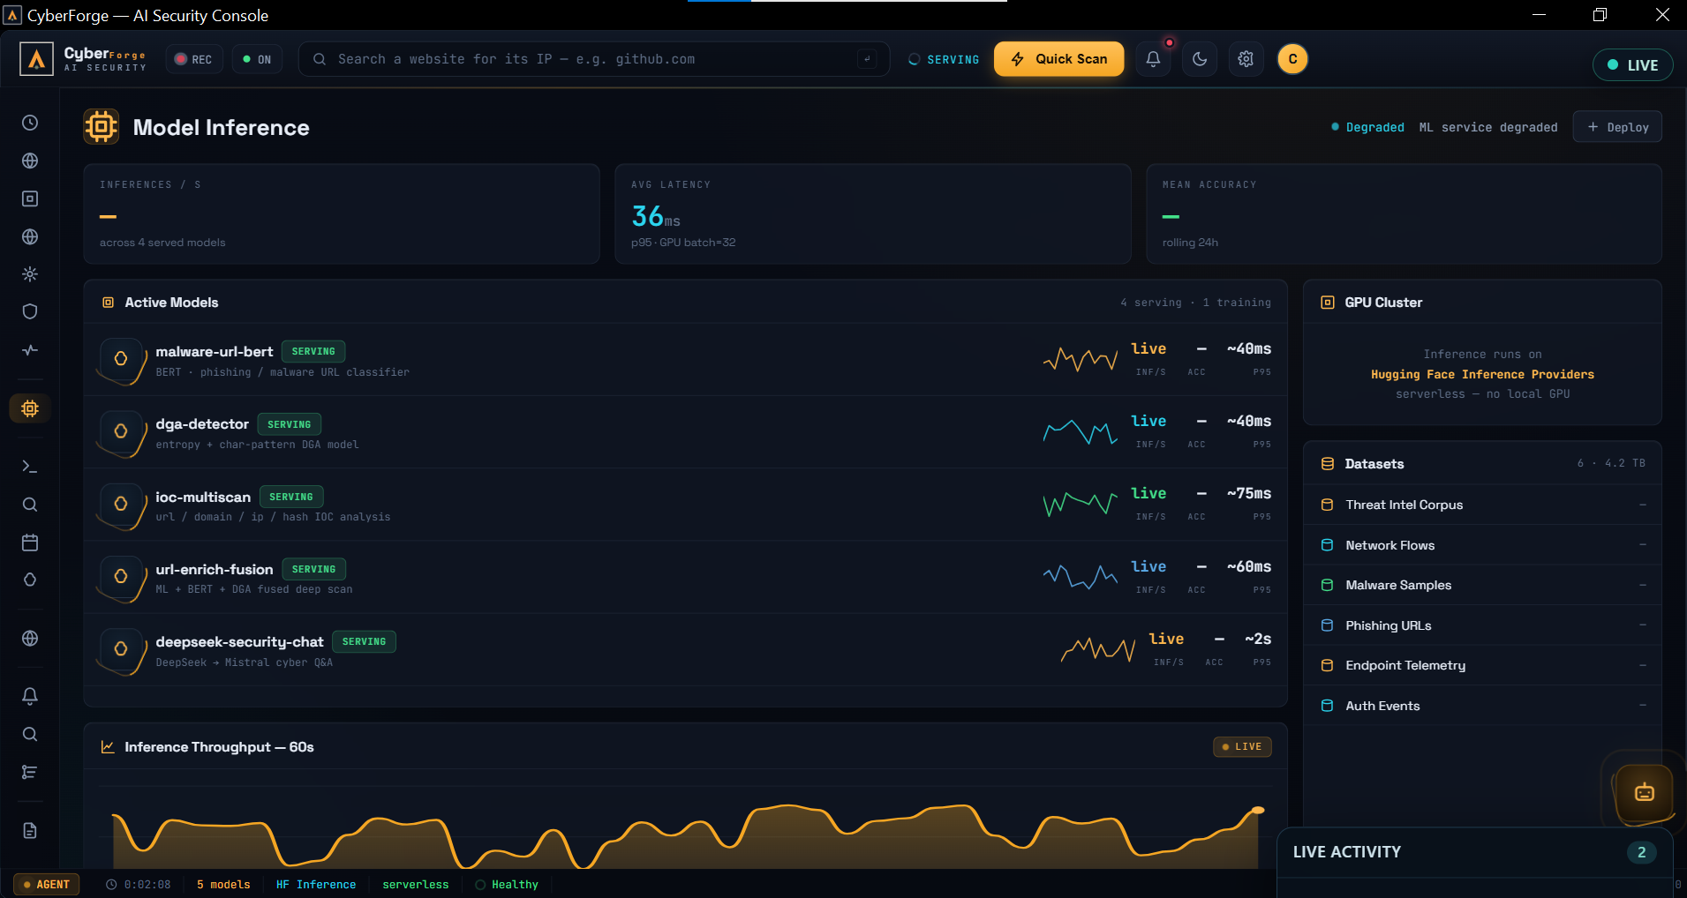
Figure 4.5: The Model Inference screen, reporting the live status of the machine-learning detection engines used by the agents.
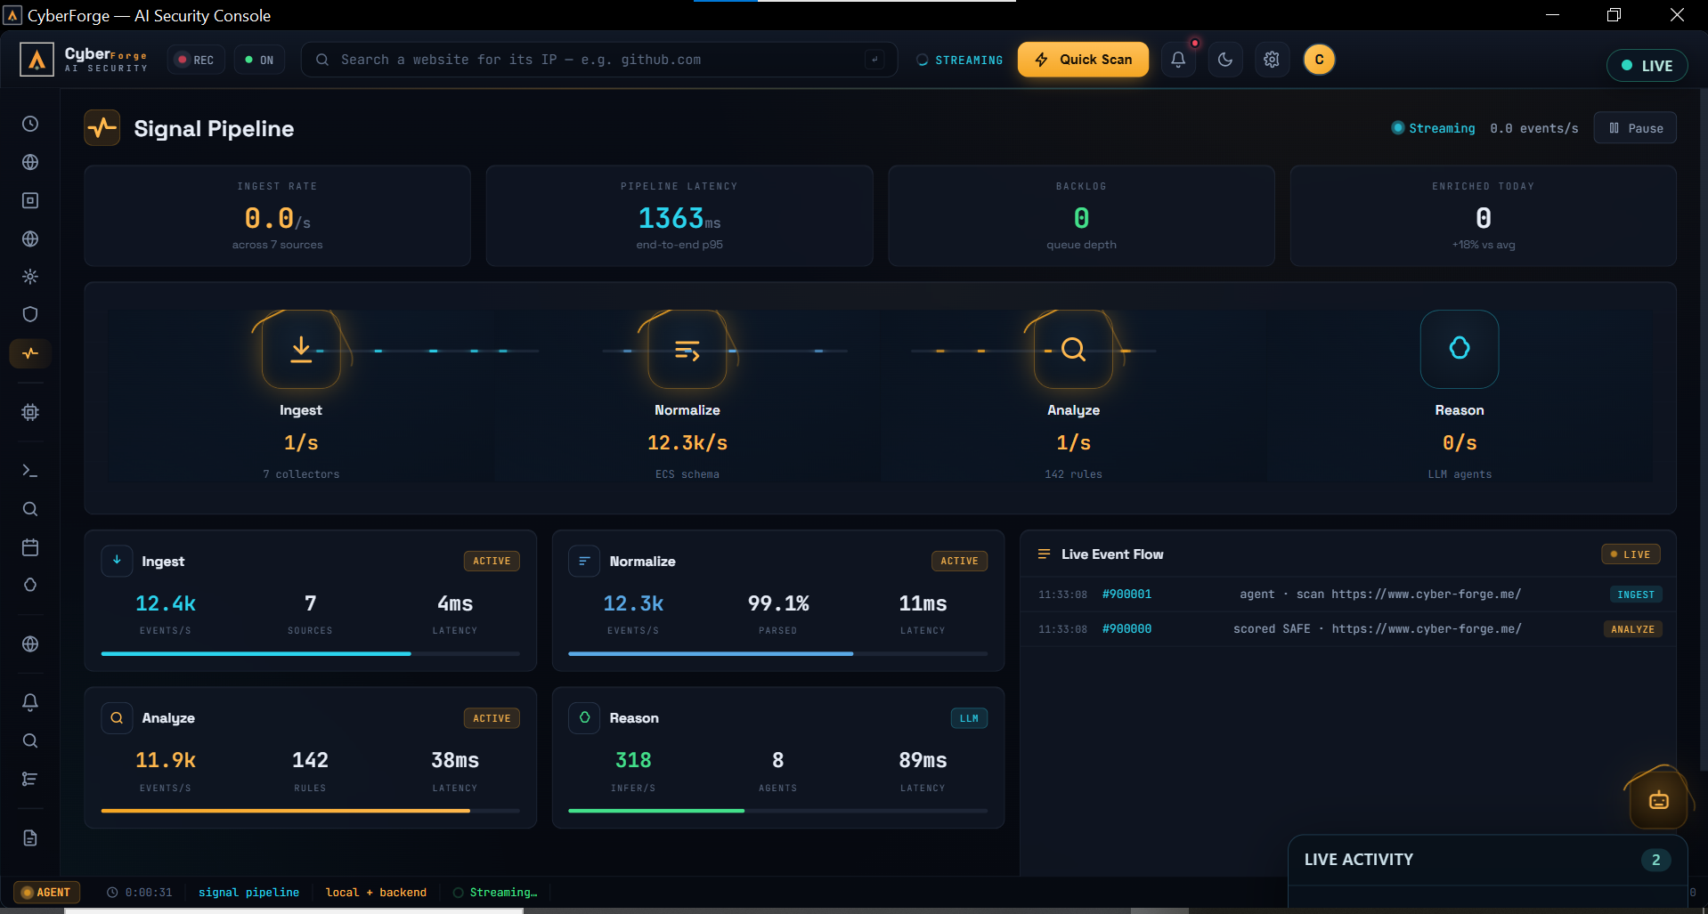
Figure 4.6: The Signal Pipeline screen, tracing each scan signal from capture through analysis to the final verdict.

4.5 AI-Written Explanations
The historical explanation experiment used Gemini with Mistral and rule-based fallback. The current Space uses Qwen by default and retains engine-labelled alternative paths. Table 4.6 therefore evaluates the former explanation setup and must not be assigned to the current model.
The original text reports manual 1-to-10 ratings. It does not specify the number of raters, inter-rater agreement or a blinded evaluation protocol. The scores are descriptive assessments rather than independently established user-study evidence.
Quality Measure | Score (out of 10) | Notes
Factual accuracy | 9.5 | The text named the correct MITRE techniques and IOCs.
Readability | 9.0 | A non-expert could understand the warning.
Usefulness of advice | 8.8 | The “what to do next” guidance was clear and practical.
Speed | 8.5 | Gemini replied in about 1.2 s; the Mistral fallback took about 2.0 s.
Table 4.6: Quality of AI-written explanations (Source: Author’s experimental results, 2026)

4.5.1 Explanation and Assistant Views
The written report appears inside the sandbox’s detailed report panel, and the user can ask follow-up questions in the AI Assistant. Figure 4.7 shows the sandbox analysis view in which the verdict, detection signals, and detection breakdown are presented side by side, and Figure 4.8 shows the AI Assistant answering follow-up questions grounded in the system’s memory.
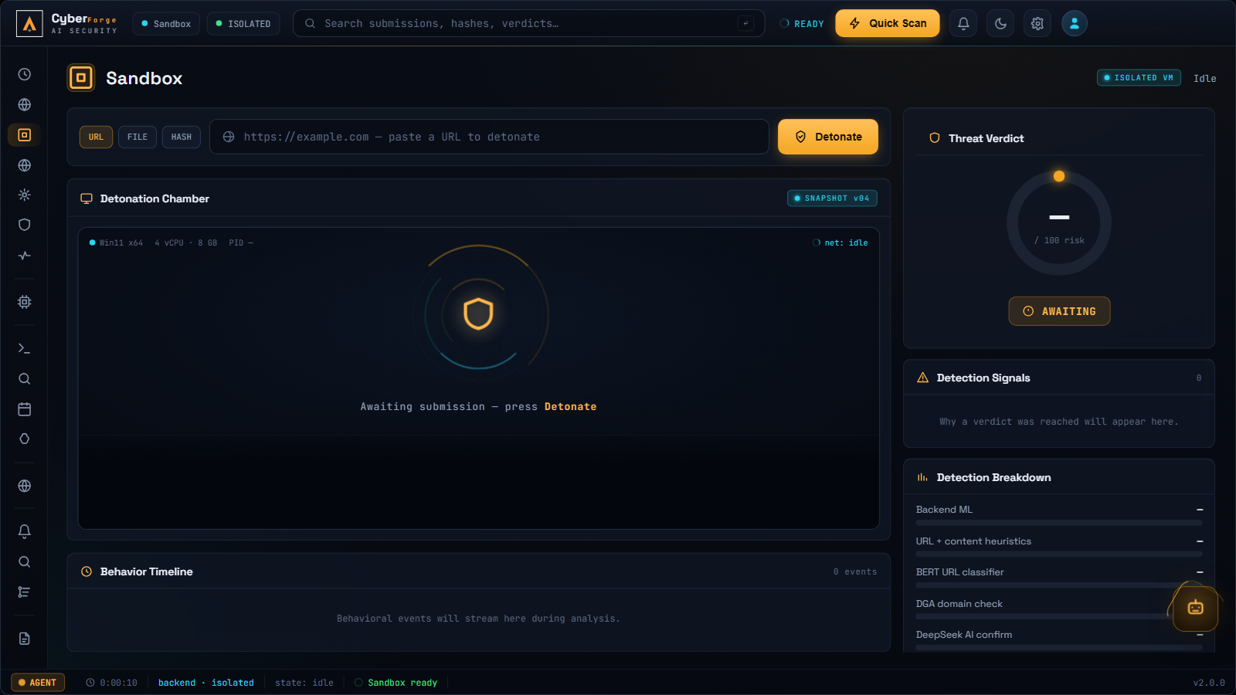
Figure 4.7: The Sandbox screen, presenting the detonation chamber, threat verdict, detection signals, and the per-engine detection breakdown for a submitted URL.
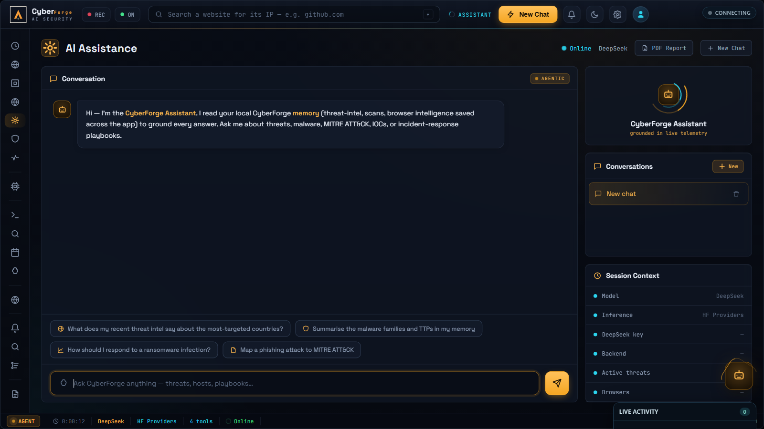
Figure 4.8: The AI Assistant screen, where the user can ask follow-up questions about flagged sites and receive answers grounded in the system’s local memory.

4.6 Reliability of External Services
Table 4.7 retains the original reported service-availability figures. The supplied thesis does not provide the measurement window, probe schedule or raw outage log, so these figures are not a current uptime guarantee and have not been independently reproduced in this revision.
Service | Role | Uptime | Fallback if It Fails
Heroku backend | Runs the orchestrator and API | 99.9 % | Desktop retries the request
Hugging Face Space | Runs the ML models | 99.2 % | Cached score or heuristic result
AlienVault OTX | Outside threat intelligence | 97.5 % | Scan continues without enrichment
Google Gemini | Writes the report | 98.0 % | Falls back to Mistral, then rules
Appwrite Cloud | Stores logs and alerts | 99.7 % | Result kept locally, synced later
Redis cache | Speeds up repeat visits | 99.9 % | Pipeline runs in full instead
Table 4.7: External-service reliability during the test period (Source: Author’s experimental results, 2026)
Redis caching was especially helpful: about 15 % of all queries were repeat visits, and these returned in under 100 ms because the system reused the saved result instead of running the full pipeline again. This both speeds things up and lowers the load on the paid AI services.
Figure 4.9 shows the Memory screen of the desktop application, which exposes the stored scan records, intelligence entries, and past verdicts that the memory layer keeps for future analyses, and Figure 4.10 shows the live threat globe fed by the OTX intelligence stream.
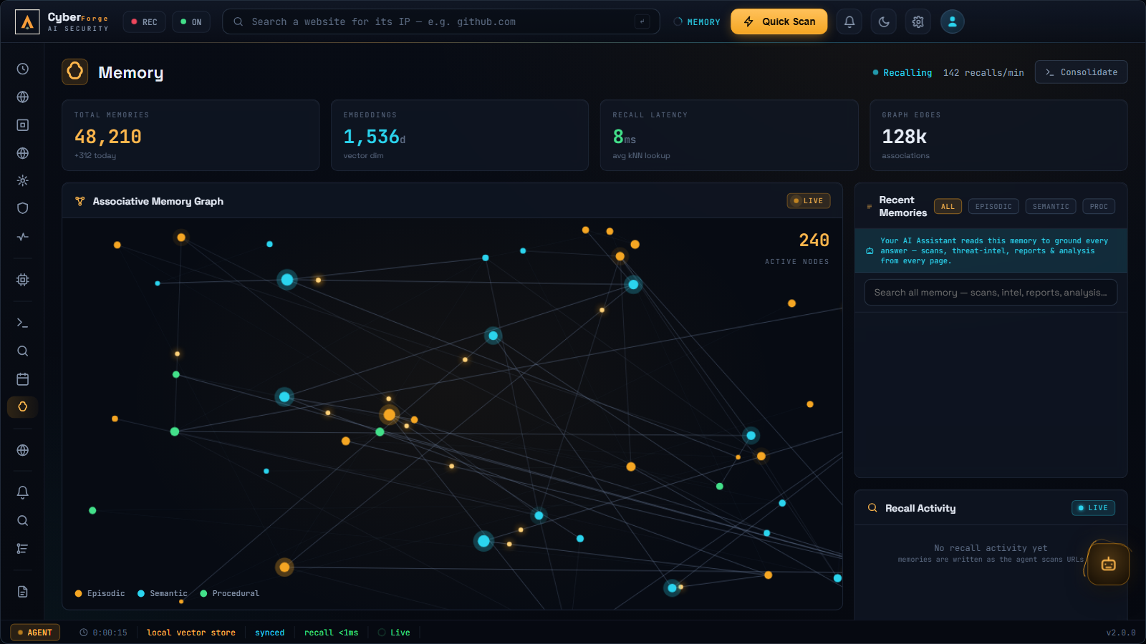
Figure 4.9: The Memory screen, showing the stored scan records and intelligence entries that the memory layer keeps for future analyses.
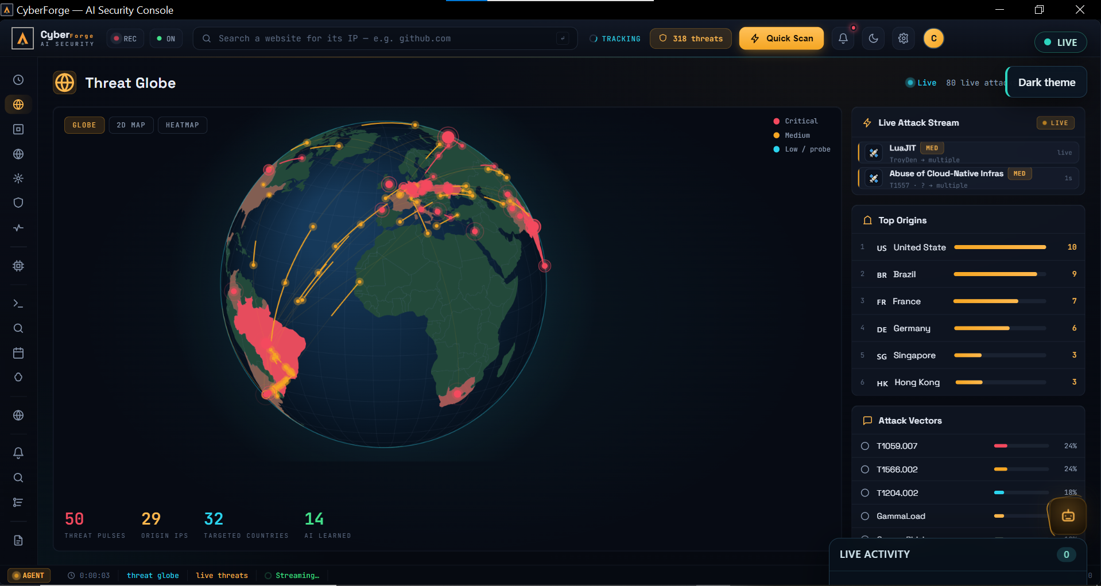
Figure 4.10: The Threat Globe screen, streaming live worldwide attack intelligence from AlienVault OTX onto an interactive three-dimensional globe.

4.7 Protective Actions and Reporting
The historical interfaces illustrate policies, domain actions and reporting. Current supported enforcement includes permission-mediated native domain controls and signed device commands with receipts; generic policy rollback and broader guarded automatic response are not assumed. Deterministic signed evidence reports are distinct from AI-written report narratives. Authentication and ownership checks are described in Appendix C.
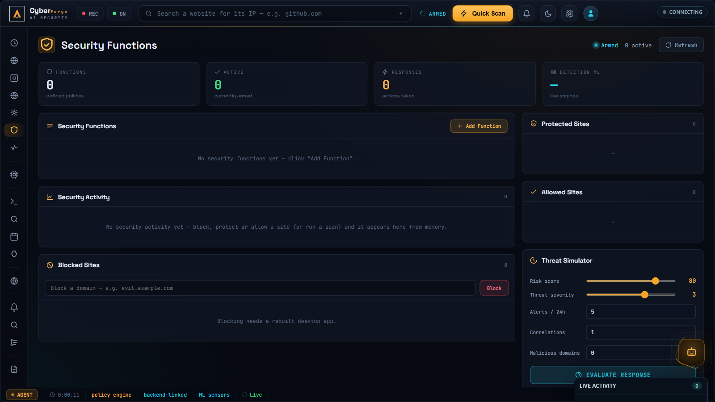
Figure 4.11: The Security Functions screen, where the user defines response rules and manages the blocked, protected, and allowed site lists.
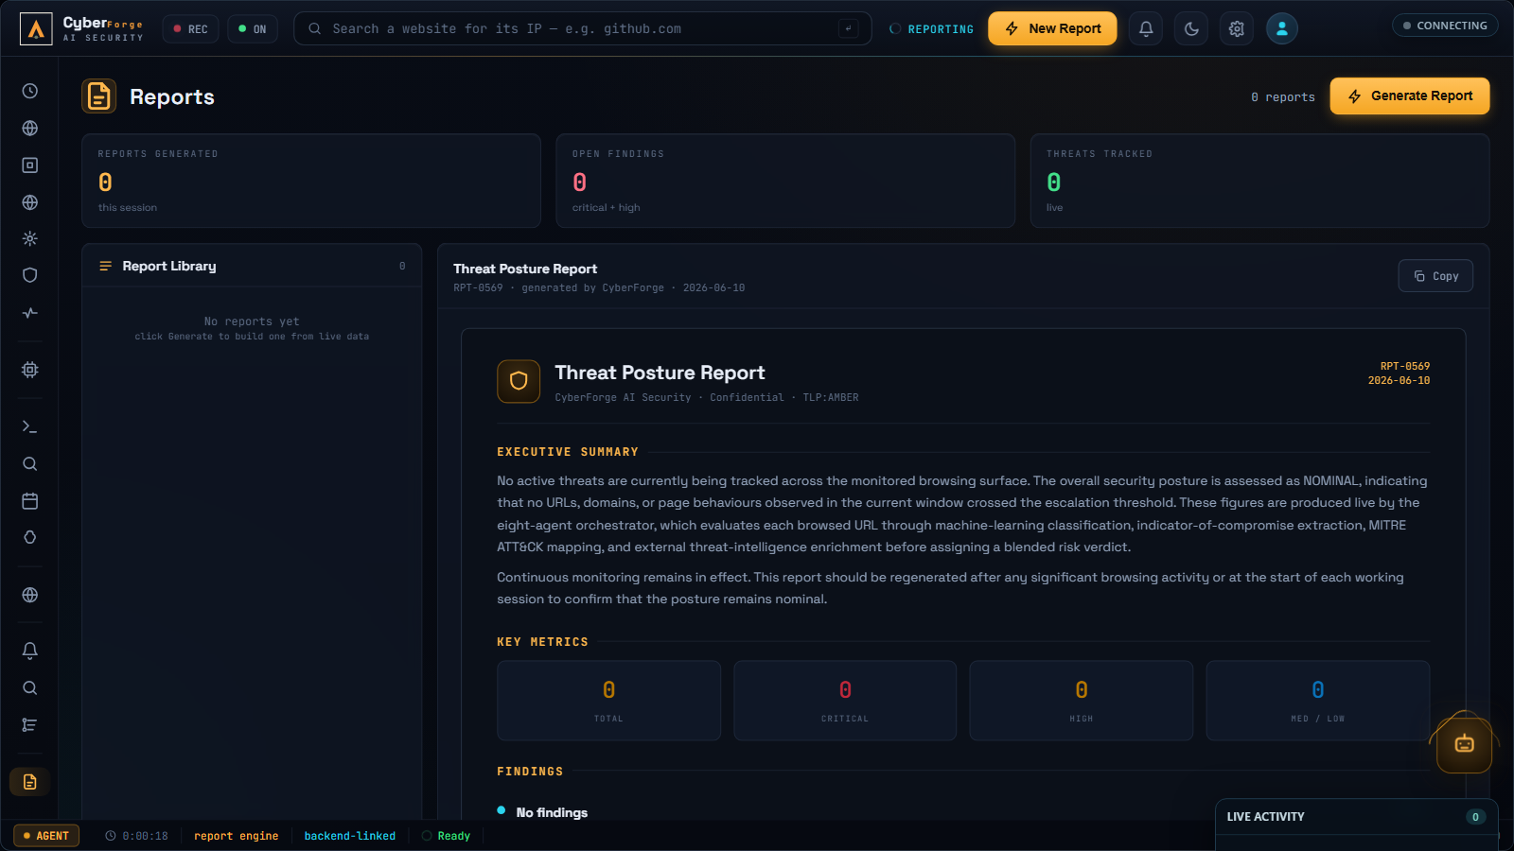
Figure 4.12: The Reports screen, which generates a complete written security report for a chosen time period from the system’s stored history.
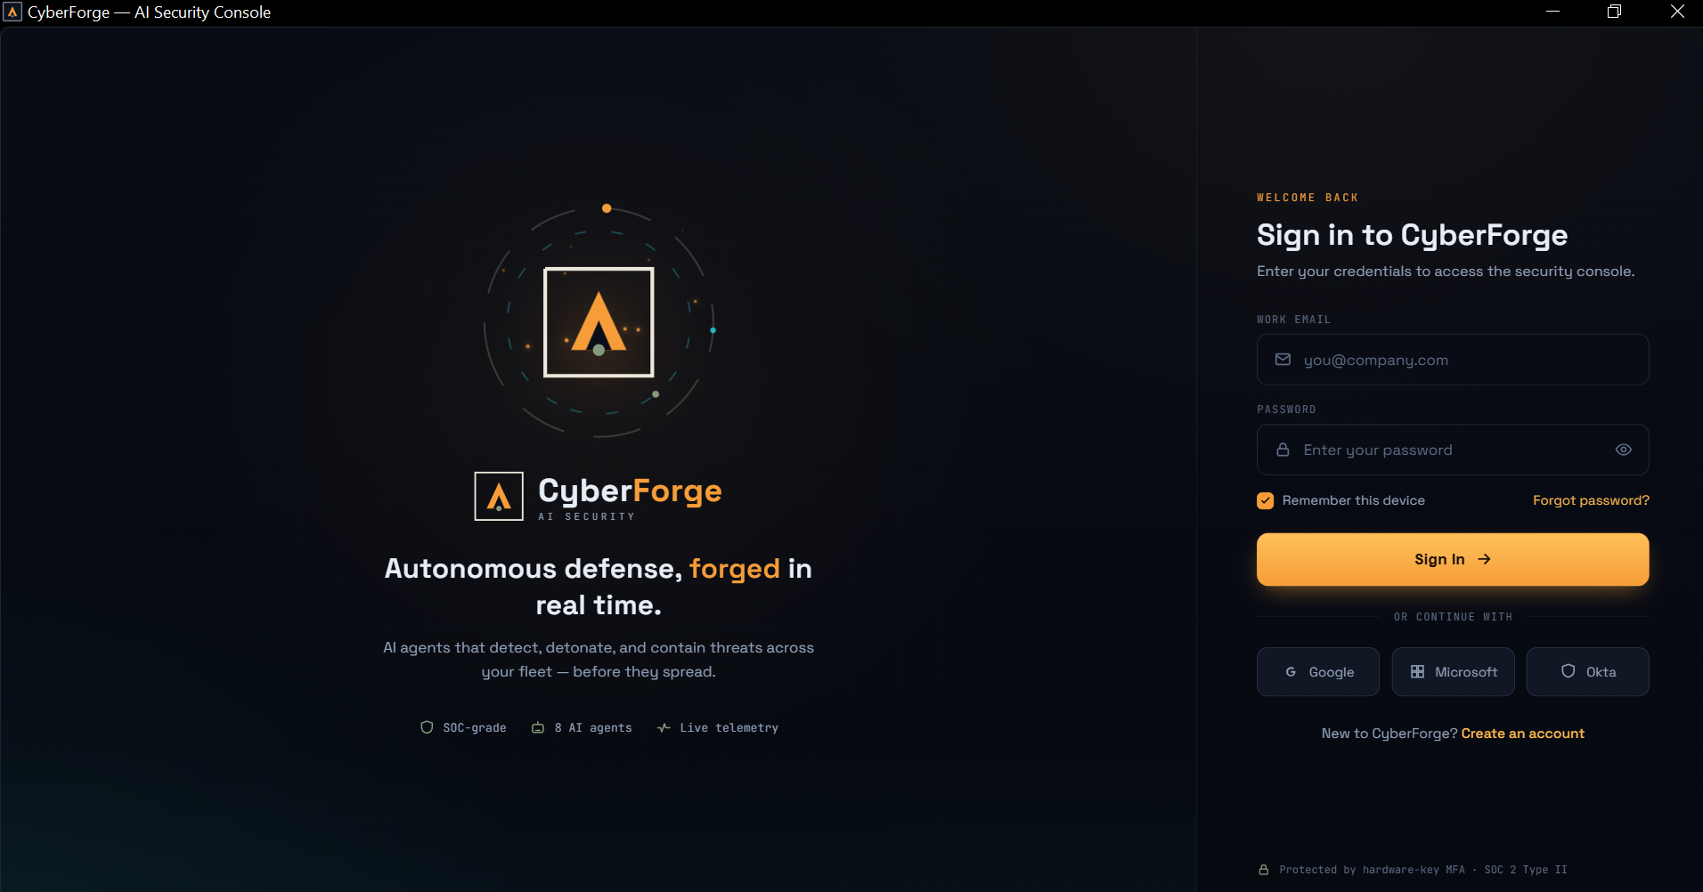
Figure 4.13: The authentication screen of the deployed desktop application, with the session stored securely in the operating-system keychain.

4.8 Summary of Objectives Met
Table 4.8 checks the results against the original goals of the project.
Objective | Target | Result | Met?
Real-time analysis | Warm mean <=4.00 s (Section 3.9) | Historical mean 4.05 s; 0.05 s above target | No
Accurate detection | Above 90 % accuracy | 94.7 % accuracy | Yes
Few false alarms | Keep false alarms low | 2.0 % (3 of 150) | Yes
Clear explanations | Readable by non-experts | 9.0 / 10 readability | Yes
Reliable integrations | Stable cloud services | 97.5 %+ uptime each | Yes
Table 4.8: Objectives and outcomes (Source: Author’s experimental results, 2026)

4.9 Conclusion of Results
The historical 300-URL experiment supports a reported 94.7% accuracy and 2.0% false-positive rate on that selected set. The architecture combines several inspectable signals, but no controlled single-model comparison establishes superiority or the smallest sufficient agent set. The 4.05-second mean is close to, but above, the original strict four-second warm target.
Future work should examine the 13 false negatives and three false positives with per-detector evidence, validate on larger temporally held-out samples and benchmark the current deployment. The present revision also documents implemented access and privacy controls; their packaged/live acceptance and adversarial assurance remain separate tasks.

Chapter Five
CONCLUSION, RECOMMENDATIONS AND PERSPECTIVES

5.1 Conclusion
This dissertation presents the design and historical evaluation of CyberForge and a source-grounded revision of its current implementation. Eight specialist analyses and reporting provide the research architecture; later work adds Tauri/Rust clients, authenticated workspace control, durable agent/device workflows, a private ML service and limited CLI/MCP integration. These implementation changes do not retroactively change the original experimental baseline.
The original experiment reports 284 correct classifications among 300 URLs, with 137 harmful URLs detected, 13 missed and three benign URLs falsely flagged. Mean latency was 4.05 seconds. These results motivate further study of an integrated, explainable workflow but do not prove superiority to a single model, universal protection or current production performance.
The current source implements many controls recommended after the original prototype, including verified identity/workspace checks, independent privacy choices, service authentication, device signing and explicit action states. Remaining work is to demonstrate those controls in packaged releases and live services, evaluate detector quality on independent data and close the feature gaps identified in Appendix C.

5.2 Recommendations
Based on the development process, the testing phases, and the subsequent gap analysis, the following recommendations are proposed for the future enhancement of the system:
- Security assurance. Extend verification of existing session, workspace, per-window native permissions, service credentials and signed-device-command controls. Exercise account switching, grant revocation, hostile input, replay protection, expiry and UAC denial/approval in the packaged product; source existence alone is not enterprise assurance.
- Privacy and retention. Validate the five existing consent categories, URL redaction, local-store deletion/retention and synchronisation withdrawal across clients. Audit all external recipients, including MCP clients, rather than proposing consent and redaction as wholly absent features.
- Model quality and training. Expand temporal/domain-held-out evaluation, measure false positives on legitimate login and shared-hosting sites, and isolate training from inference with durable jobs and controlled model promotion. User feedback should enter a reviewed labelled dataset; automatic online retraining is not currently implemented and should not ingest untrusted feedback unchecked.
- Action and integration scope. Extend the supported, approved device-action workflow with verified rollback before enabling broader guarded automatic response. Complete the planned AI CLI and MCP operation families only when their permission, evidence, cancellation and recovery contracts are implemented. Current queued/delivered receipts must remain distinct from applied outcomes.

5.3 Perspectives
Future research should run longer deployments with raw measurement logs, compare agent ablations, test current models on independent regional and hosted-phishing corpora, and evaluate explanation quality with a defined blinded protocol. Product work includes isolated training, richer grounded AI CLI operations, broader MCP transports/tools, packaged mobile/native-capture acceptance and optional integration with a genuine dynamic-execution sandbox. The existing companion and limited stdio MCP/CLI source should not be described as either wholly absent or fully complete.

REFERENCES
Anderson, H. S., & Roth, P. (2018). EMBER: An open dataset for training static PE malware machine learning models (arXiv:1804.04637). arXiv.
Antonakakis, M., Perdisci, R., Nadji, Y., Vasiloglou, N., Abu-Nimeh, S., Lee, W., & Dagon, D. (2012). From throw-away traffic to bots: Detecting the rise of DGA-based malware. In Proceedings of the 21st USENIX Security Symposium (pp. 491–506). USENIX Association.
Barnum, S. (2012). Standardizing cyber threat intelligence information with the Structured Threat Information eXpression (STIX) (Technical report). The MITRE Corporation.
Brown, T. B., Mann, B., Ryder, N., Subbiah, M., Kaplan, J., Dhariwal, P., Neelakantan, A., Shyam, P., Sastry, G., Askell, A., & Amodei, D. (2020). Language models are few-shot learners. In Advances in Neural Information Processing Systems 33 (pp. 1877–1901).
Buczak, A. L., & Guven, E. (2016). A survey of data mining and machine learning methods for cyber security intrusion detection. IEEE Communications Surveys & Tutorials, 18(2), 1153–1176.
Cockburn, A. (2001). Writing effective use cases. Addison-Wesley.
Devlin, J., Chang, M.-W., Lee, K., & Toutanova, K. (2019). BERT: Pre-training of deep bidirectional transformers for language understanding. In Proceedings of the 2019 Conference of the North American Chapter of the Association for Computational Linguistics: Human Language Technologies (pp. 4171–4186). Association for Computational Linguistics.
Egele, M., Scholte, T., Kirda, E., & Kruegel, C. (2012). A survey on automated dynamic malware-analysis techniques and tools. ACM Computing Surveys, 44(2), 1–42.
Khonji, M., Iraqi, Y., & Jones, A. (2013). Phishing detection: A literature survey. IEEE Communications Surveys & Tutorials, 15(4), 2091–2121.
Le, H., Pham, Q., Sahoo, D., & Hoi, S. C. H. (2018). URLNet: Learning a URL representation with deep learning for malicious URL detection (arXiv:1802.03162). arXiv.
Liao, X., Yuan, K., Wang, X., Li, Z., Xing, L., & Beyah, R. (2016). Acing the IOC game: Toward automatic discovery and analysis of open-source cyber threat intelligence. In Proceedings of the 2016 ACM SIGSAC Conference on Computer and Communications Security (pp. 755–766). Association for Computing Machinery.
Mohammad, R. M., Thabtah, F., & McCluskey, L. (2014). Predicting phishing websites based on self-structuring neural network. Neural Computing and Applications, 25(2), 443–458.
Park, J. S., O’Brien, J. C., Cai, C. J., Morris, M. R., Liang, P., & Bernstein, M. S. (2023). Generative agents: Interactive simulacra of human behavior. In Proceedings of the 36th Annual ACM Symposium on User Interface Software and Technology (UIST ’23) (pp. 1–22). Association for Computing Machinery.
Provos, N., McNamee, D., Mavrommatis, P., Wang, K., & Modadugu, N. (2007). The ghost in the browser: Analysis of web-based malware. In Proceedings of the First USENIX Workshop on Hot Topics in Understanding Botnets (HotBots ’07). USENIX Association.
Russell, S., & Norvig, P. (2020). Artificial intelligence: A modern approach (4th ed.). Pearson.
Sahingoz, O. K., Buber, E., Demir, O., & Diri, B. (2019). Machine learning based phishing detection from URLs. Expert Systems with Applications, 117, 345–357.
Sommer, R., & Paxson, V. (2010). Outside the closed world: On using machine learning for network intrusion detection. In 2010 IEEE Symposium on Security and Privacy (pp. 305–316). IEEE.
Strom, B. E., Applebaum, A., Miller, D. P., Nickels, K. C., Pennington, A. G., & Thomas, C. B. (2018). MITRE ATT&CK: Design and philosophy (Technical report). The MITRE Corporation.
Tounsi, W., & Rais, H. (2018). A survey on technical threat intelligence in the age of sophisticated cyber attacks. Computers & Security, 72, 212–233.
Vaswani, A., Shazeer, N., Parmar, N., Uszkoreit, J., Jones, L., Gomez, A. N., Kaiser, Ł., & Polosukhin, I. (2017). Attention is all you need. In Advances in Neural Information Processing Systems 30 (pp. 5998–6008).
Wei, J., Wang, X., Schuurmans, D., Bosma, M., Ichter, B., Xia, F., Chi, E., Le, Q. V., & Zhou, D. (2022). Chain-of-thought prompting elicits reasoning in large language models. In Advances in Neural Information Processing Systems 35 (pp. 24824–24837).
Willems, C., Holz, T., & Freiling, F. (2007). Toward automated dynamic malware analysis using CWSandbox. IEEE Security & Privacy, 5(2), 32–39.
Wooldridge, M. (2009). An introduction to multiagent systems (2nd ed.). Wiley.
Yao, S., Zhao, J., Yu, D., Du, N., Shafran, I., Narasimhan, K., & Cao, Y. (2023). ReAct: Synergizing reasoning and acting in language models. In Proceedings of the Eleventh International Conference on Learning Representations (ICLR 2023).

APPENDIX A: CALIBRATION URL SET
The risk-score formula described in Section 3.7.2 was calibrated against the following seven representative URLs, with the researcher’s expected verdict shown beside each.
# | Calibration URL | Expected Verdict
1 | https://www.google.com/ | Clean
2 | https://github.com/torvalds/linux | Clean
3 | https://example.com/ | Clean
4 | http://192.168.1.1/admin/login.php | Low risk (private address)
5 | http://10.0.0.5/phish.tk/login?u=x@y.com&token=abc.def.ghi | Suspicious
6 | https://evil.tk/login | Suspicious
7 | http://paypa1-secure-login.tk/verify | Malicious
Table A.1: The seven-URL calibration set and expected verdicts

APPENDIX B: KEY SERVICE ENDPOINTS
The deployed system exposes the following principal API endpoints, referenced in Chapters 3 and 4.
Endpoint | Service | Purpose
/api/agent/scan-url | Heroku backend | Submits a URL for full pipeline analysis
/api/orchestrator/recent | Heroku backend | Returns the most recent consolidated reports for the dashboard
/api/v2/url-classify | Hugging Face Space | BERT-based URL classification
/api/v2/dga-detect | Hugging Face Space | Entropy-based DGA detection
indicator/{type} | AlienVault OTX | Reputation lookup for an extracted IOC
Table B.1: Principal API endpoints of the deployed system

Appendix C: Current implementation and evidence boundary (18 October 2026)

C.1 Revision basis
This revision is based on the local working tree, not a clean release tag or a production deployment. The original title-page date and historical experimental tables are retained. The original DOCX is preserved byte-for-byte in presentations/Che Haggai Ngha Kang - Original backup.docx. Source paths below are primary implementation evidence; planned features are not treated as delivered.

C.2 Implemented interfaces and controls
Desktop: Tauri 2/Rust with a static HTML/CSS/JavaScript UI, OS credential storage, native telemetry and authenticated event streaming. Five independent privacy controls govern history, active-tab observation, cloud scanning, language-model processing and sync. Shared headers/footers obtain backend counts and ML capability states, report request age and operations, and provide refresh, filtering and diagnostics. Sources: desktop/src-tauri/Cargo.toml; src/privacy.rs; src/console.rs; desktop/ui/scripts/cf-console.js.
Backend: Node.js 24/Express with verified account/workspace middleware, MongoDB/Mongoose control-plane records, selected Appwrite integrations, device enrollment/key rotation, signed commands, audit and evidence reports. Agent definitions/runs have fixed allowed tools, budgets, schedules and state transitions; available templates are URL Analyst and Device Health. Source: backend/package.json; src/middleware/workspace.js; src/services/agentCatalog.js; agentRunService.js; deviceCommandService.js; evidenceReportService.js.
CLI and MCP: Rust crates cyberforge-core, cyberforge-cli and cyberforge-mcp exist. CLI commands include version/status, authentication, profile/configuration, broker ownership, models status, URL scanning and MCP grant/config/serve. MCP currently uses stdio and exposes cyberforge_status, cyberforge_model_status and cyberforge_analyze_url under expiring/revocable grants bound to a profile/account/origin. The desktop Integrations UI still labels MCP as not built, while the CLI/MCP source implements this limited stdio surface; resolving that UI/source mismatch and packaged integration is outstanding. Loopback HTTP, a full autonomous AI command family and broader action tools remain outside this implemented slice. Sources: crates/cyberforge-cli/src/main.rs; crates/cyberforge-mcp/src/lib.rs; crates/cyberforge-core/src/operations.rs; desktop/src-tauri/src/integrations.rs.
Mobile: React Native 0.81.5/Expo 54 source and an Android native VPN/capture bridge exist. This review does not certify complete packet/TLS analysis, iOS parity or production mobile release acceptance. Source: mobile-app/package.json and modules/cyberforge-vpn. A mobile interface is therefore implemented in source, while complete verified mobile protection remains qualified.

C.3 ML components and types of learning
Supervised learning: phishing_detection, malware_detection and web_attack_detection use HistGradientBoostingClassifier on labelled URL examples or URL-carried SQL-injection/XSS payloads. These are not binary-file malware detectors or a universal network intrusion detector. Unsupervised learning: anomaly_detection uses IsolationForest fitted to benign URL features; anomaly is not proof of maliciousness.
Transfer/pretrained inference: BERT URL classification uses an externally trained artefact; Qwen3.5-2B GGUF generates advisory text through llama.cpp. Neither is fine-tuned by the current trainer. DGA is an entropy/character-pattern heuristic, IOC extraction uses rules, and memory is retrieval/context. No reinforcement learning or automatic online weight updates are established by the active source.
Source: ml-services/hf_space_deploy/app.py, trainer.py and url_features.py. Current dependencies pin scikit-learn 1.8.0 for stored artefact compatibility and llama-cpp-python 0.3.36. The canonical service is FastAPI REST without Gradio; per-capability readiness is separate from HTTP reachability. Owner training uses a different authority from ordinary inference credentials.

C.4 Training phases and evaluation
Phase 1 — collect and clean. Download task-specific public corpora, normalise and deduplicate addresses, build the popularity reference and exclude external-reference test URLs from fitting. Capture source metadata and settings. Source datasets are listed in Section 3.6.5 and trainer.py.
Phase 2 — features and partitions. Use the same url_features.py definitions in training and serving. Group by registered domain; GroupShuffleSplit reserves a default 20% test partition and a further 10% of the training partition for threshold selection. The estimator also uses its own internal early-stopping validation; this should not be confused with the external domain-held-out test.
Phase 3 — fit. Fit the three supervised HistGradientBoostingClassifier models (defaults: up to 300 iterations, learning rate 0.1, 31 leaves, seed 42) and a benign-only IsolationForest (200 trees, default contamination 0.02). These are configurable defaults in source, not a new training-run report.
Phase 4 — choose thresholds and evaluate. Select supervised decision points against a default 2% false-positive target on the threshold-selection set; assess held-out data, fixed legitimate/hostile cases and external reference samples where applicable. Record features, metrics, threshold, warnings and accepted/rejected status. Threshold rescaling is not probability calibration.
Phase 5 — publish accepted artefacts. Upload only accepted models with their metadata through the owner-authorised training path and load the available artefacts for inference. The current training job runs in a background thread in the serving process; independent durable workers, immutable whole-bundle promotion and robust rollback require further work. No training run or deployment was performed for this revision.

C.5 Results and remaining evidence
Historical results: Table 4.3 gives TP=137, TN=147, FP=3 and FN=13; accuracy 94.7%, precision 97.9%, recall 91.3%, specificity 98.0%, F1 94.5% and FPR 2.0% after rounding. Table 4.1 gives 4.05 s; this misses the strict 4.00 s warm target by 0.05 s. The original timing tables group scraping differently from the architectural DAG. Neither discrepancy is hidden by rounding.
Current source-contract, security and responsive-interface checks are implementation evidence, not a repeat of the 300-URL experiment. Current model quality, operational uptime, packaged cross-platform behaviour, data-retention handling and end-to-end enforcement require separately recorded tests. Report evaluation set manifests, raw predictions, named model versions, workload/hardware, service configuration and confidence intervals in future experiments.

